Demo and guidance of the commanding and dispatching system of OortCloud Police Treasure
https://www.oortcloudsmart.com

Application account and password

188 1111 0001
188 1111 0002
188 1111 0003
……
188 1111 0030

password 123456
It is recommended to use the latter account。
Role account
Director account | 188 1110 0001——188 1110 0015 | 15 in total | password 123456
Sub-director's account | 188 1110 0021——188 1110 0030 | 10 in total | password 123456
Police station Director account | 188 2222 0001——188 2222 0010 | 10 in total | password 123456
Station master account | 188 2222 0021——188 2222 0030 | 10 in total | password 123456

目 录
一、 How to install and use the Police Treasure 2
二、 The linkage between the Police Treasure and the large-screen command and dispatch 6
三、 Demo steps 8
（一）Informatization within the unit 8
（二）Police Situation Map 10
（三）Examples of use 11
1、How to view fixed point cameras? 11
2、How to check the mobile video return？ 11
3、Executable program (.exe) version on Windows 13
4、Video conference 15
四、 Presentation renderings 16
Attachment: Pingwubao background demonstration for customer-side operation and maintenance management 20
（一）Log in to the backstage of police treasure 20
（二）Add users and organizations 21
（三）Administrator control background 22
（四）App developer background 22
（五）One Map on the PC Web 23
（六）App data management background 23
（七）110 police management background 24
1、Police data can be recorded by hand 24
2、Alarm data can be imported in batches 25
3、Alarm data can be docked 25
（八）One Map data management background 26
（九）Other data management background 27

How to install and use the Police Treasure
- Way 1: Huawei IdeaHub installation
In the HUAWEI application market(AppGallery), directly search for "警务宝",or “jingwubao”, the large-screen versionDownload the app and install it on Huawei IdeaHub。
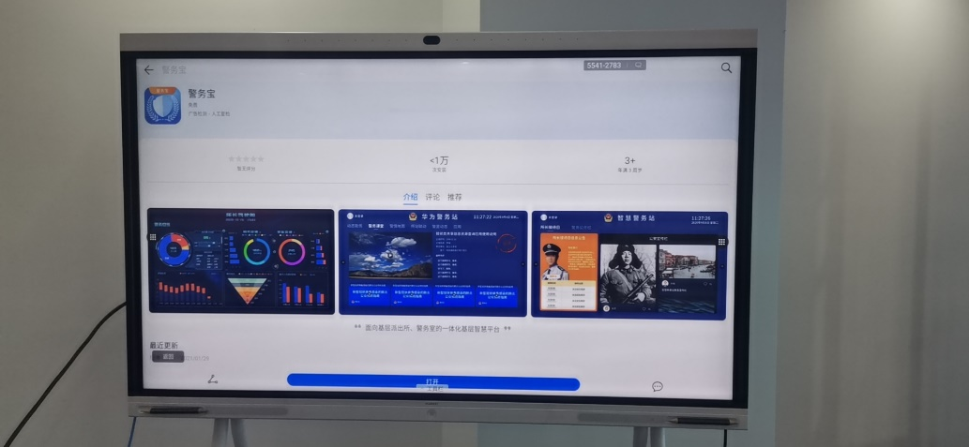

Or open this link to download the apk and install
https://appgallery.huawei.com/#/app/C103699063

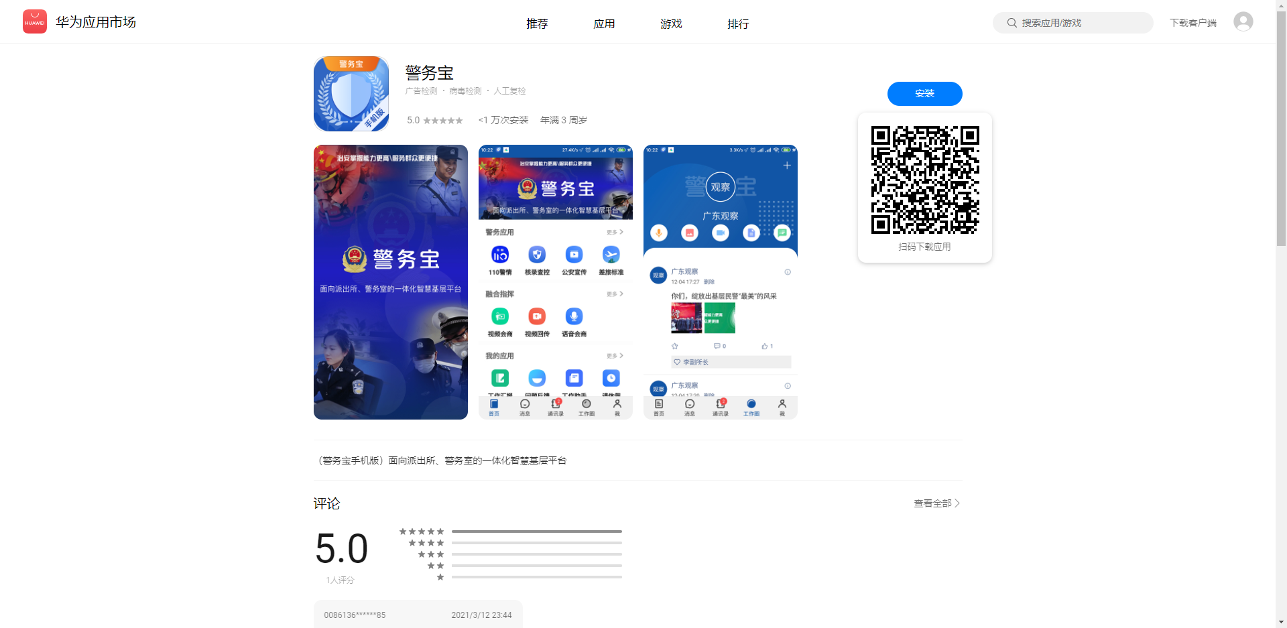

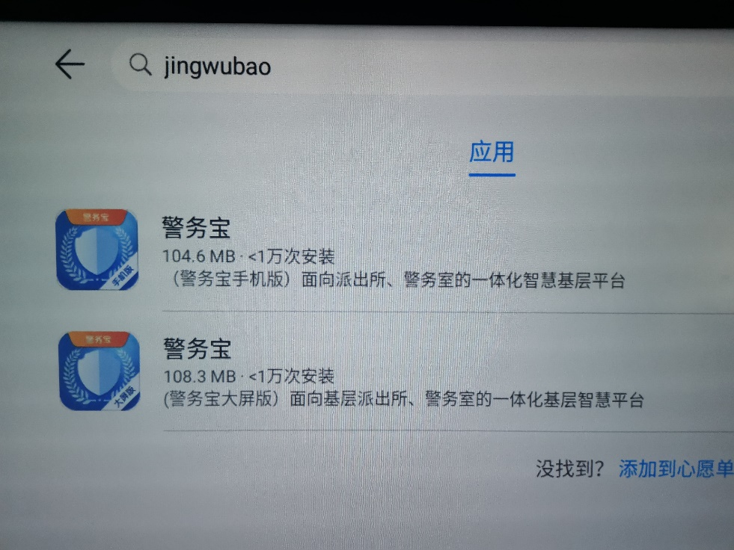
Enter “jingwubao” search ,
The first is the mobile version, the second is the large-screen version

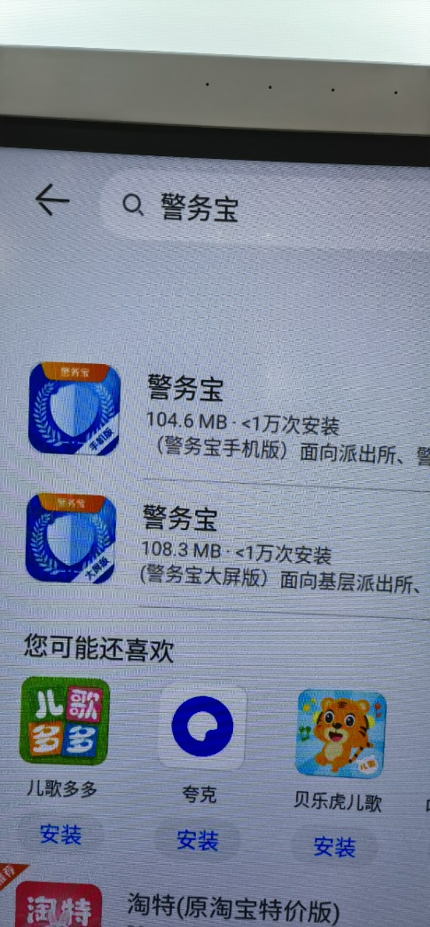
Enter the “警务宝” or “jingwubao”, click search, you can find the large-screen version (enterprise smart screen) and mobile version of the Police Treasure

- Way 2: cast using a Windows computer screen, or plug OPS module on IdeaHub
One map of the Police Treasure's command and dispatch can be demonstrated separately
Open the URL in Google Chrome：
http://map.oort.oortcloudsmart.com:18080/onemap/main.jsp
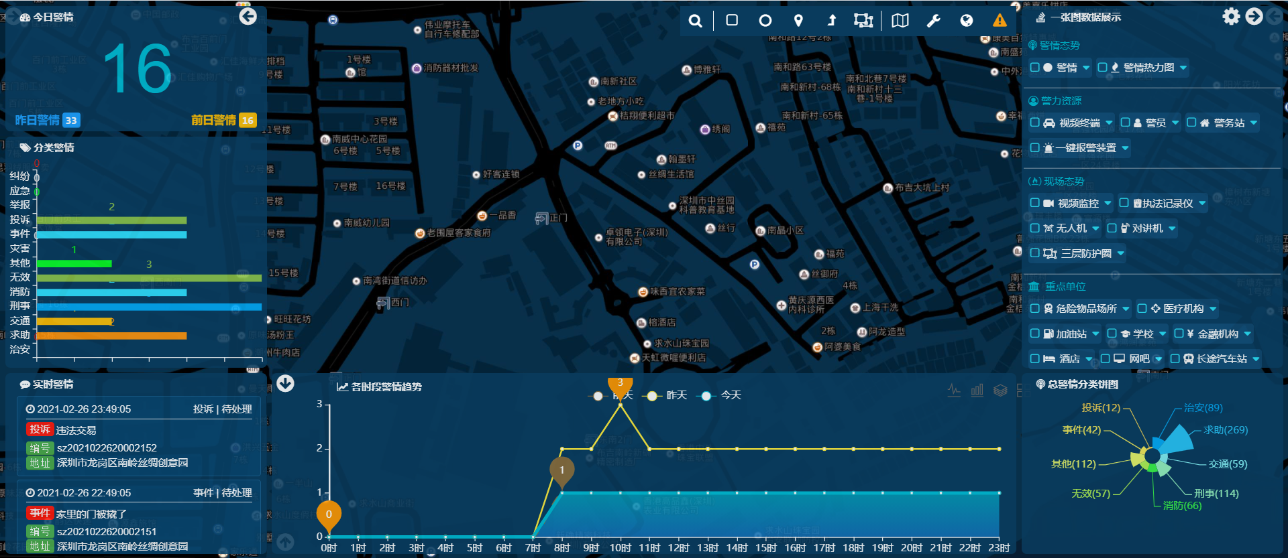

- Demo: Linkage between mobile phone and IdeaHub or Windows (PC projection/OPS)
- Download and install the Police Treasure application from the Huawei mobile app market.
- Open the Police Treasure on the mobile phone, and turn on the "video Live".
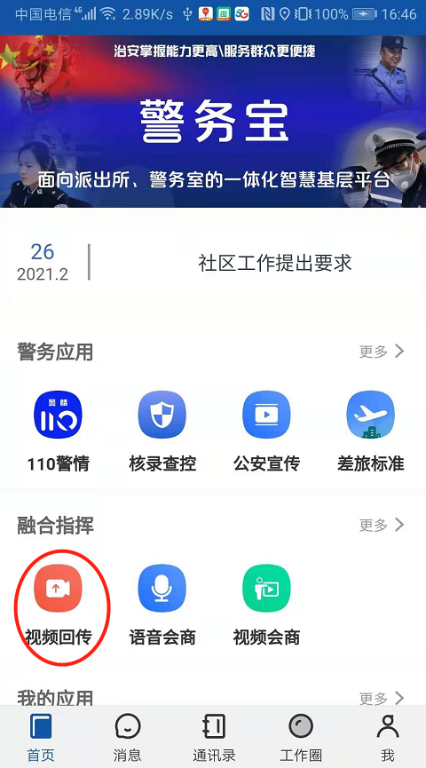

- You can see the video displayed on the big screen, as shown below。
Note: The video from multiple mobile phones can be displayed simultaneously when the video is sent back. Currently, Android supports up to three videos and Windows9.
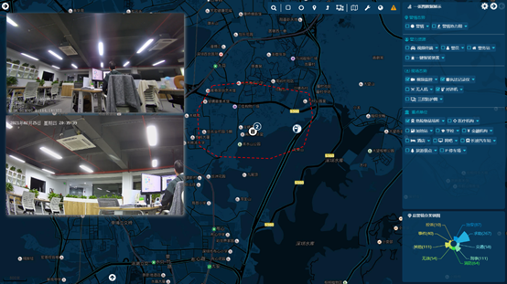

The linkage between the Police Treasure and the large-screen command and dispatch
Plug in the HDMI cable of the large screen to IdeaHub Police Treasure, and find the screen clone in IdeaHub settings. At this time, the content displayed by IdeaHub will be displayed on the big screen at the same time。
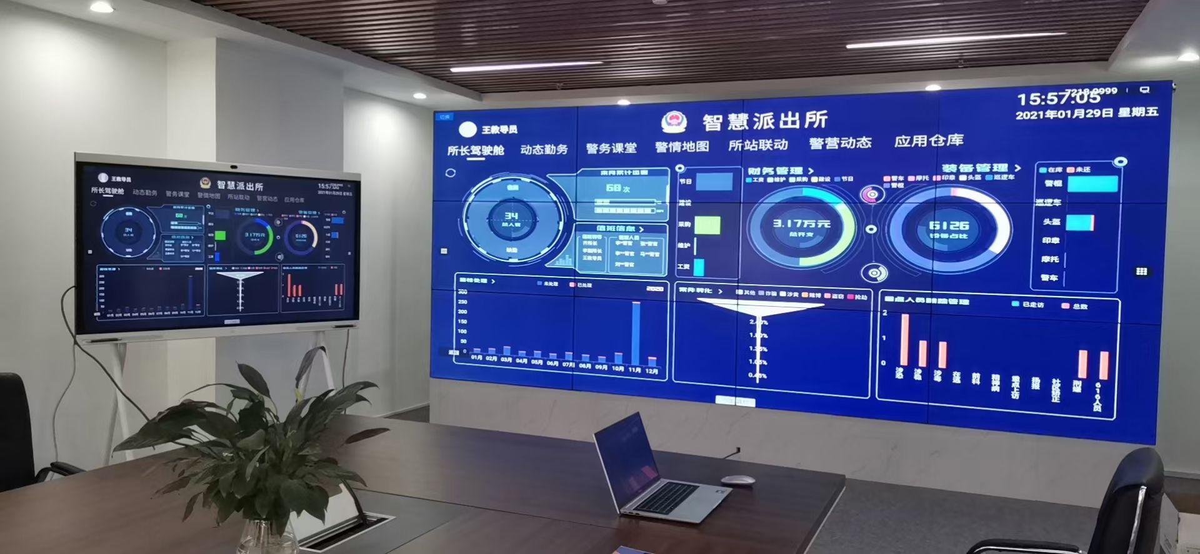

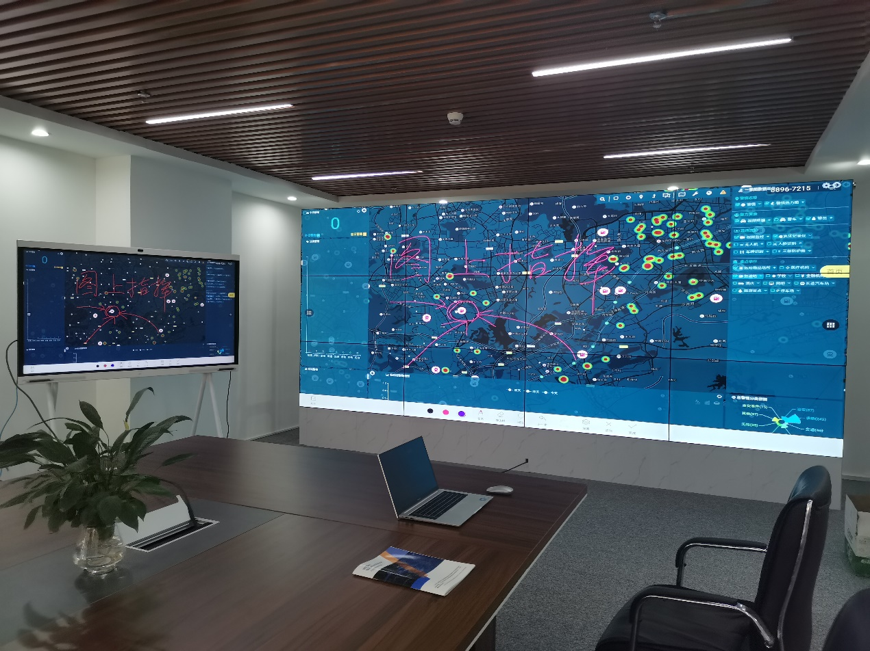

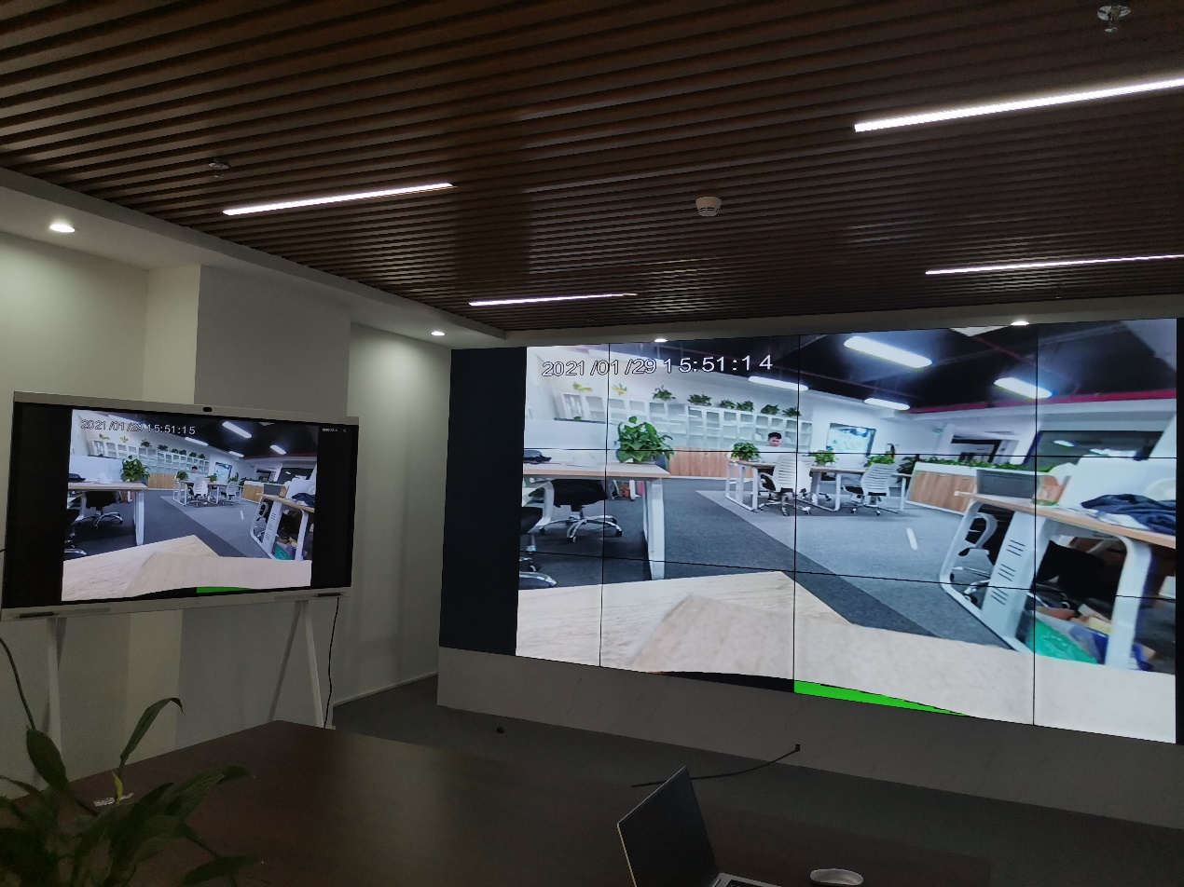

Demo steps

（一）Informatization within the unit
Based on the director cockpit. Explain a screen overview of the work in the office. Explanations and demonstrations of functions such as police classroom, station linkage (for meetings with less than 9 parties, and for more than 9 parties to connect to Huawei MCU or Huawei Cloud), dynamic services, application warehouses, etc.。
- From the perspective of the director (login account number 188 1110 0001-188 1110 0015, a total of 15; password 123456)
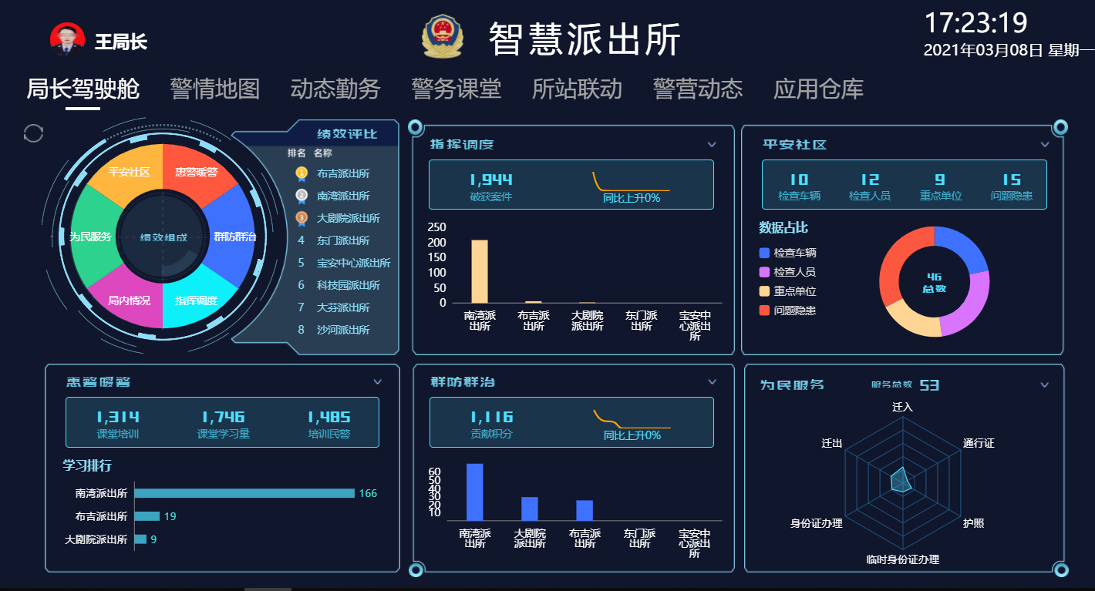

- The sub-director’s perspective (login account number 188 1110 0021-188 1110 0030, 10 in total; password 123456)

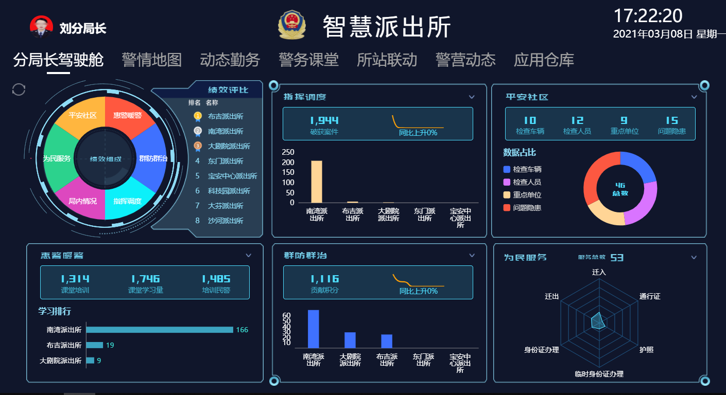

- Director’s perspective (login account number 188 1111 0001, 188 1111 0002, 188 1111 0003, 188 1111 0004, 188 2222 0001-188 2222 0010 in total 14; password 123456
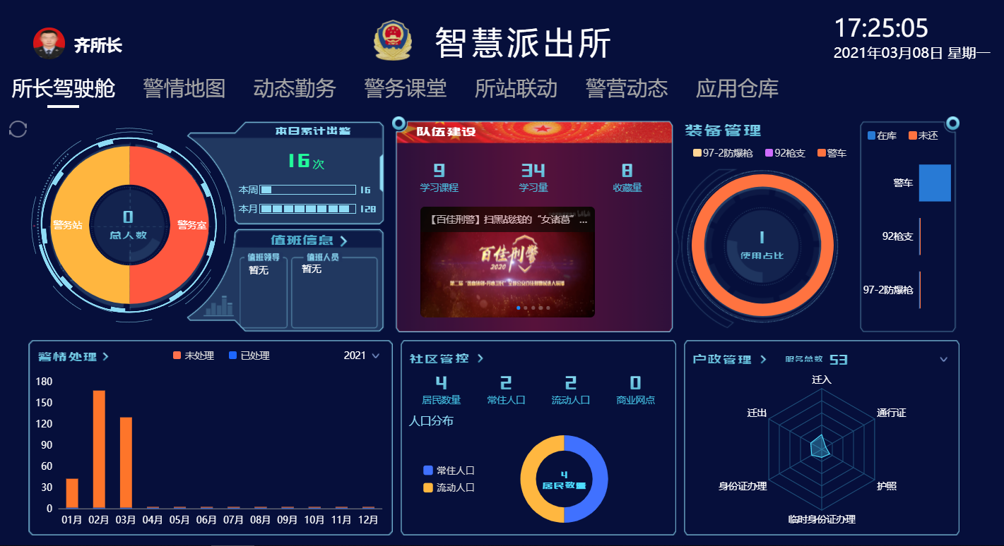

- From the perspective of the webmaster (login account number 188 2222 0021-188 2222 0030 10 in total; password 123456)
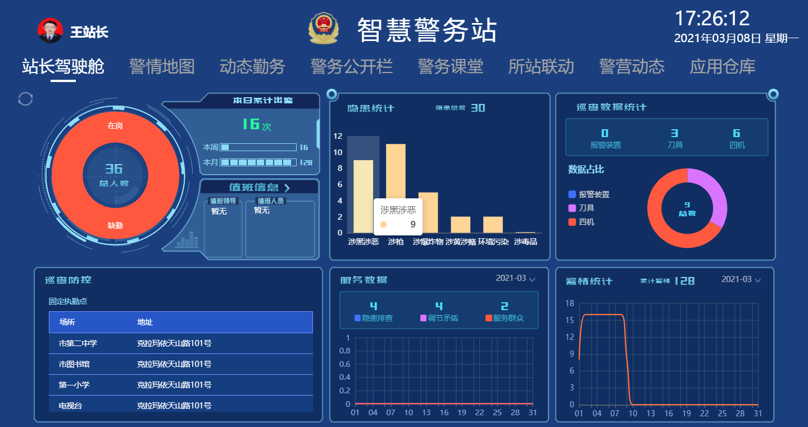

（二）Police Situation Map
Focus on the police situation map, open the police situation map on the Police Treasure, and demo one map command。

Process：
Where is the police situation occurred (select the Nanwan Police Station in the upper right corner), turn on the surrounding cameras, look at the scene, turn on the key unit layer to see if there are any key units nearby, and then turn on the police force layer to see which police force is dispatched And open the live video of the police force。

Show off：
1. The above picture of the alarm position
2. Show the location of the police force on the map in real time
3. Click on the police force to query the video of the law enforcement recorder. The Police Treasure App can be installed on the mobile phone to simulate the video upload of the mobile device terminal.
4. Query the real-time video and historical video of a fixed monitoring point.
5. Check whether there are any key units nearby.

（三）Examples of use

1、How to view fixed point cameras?
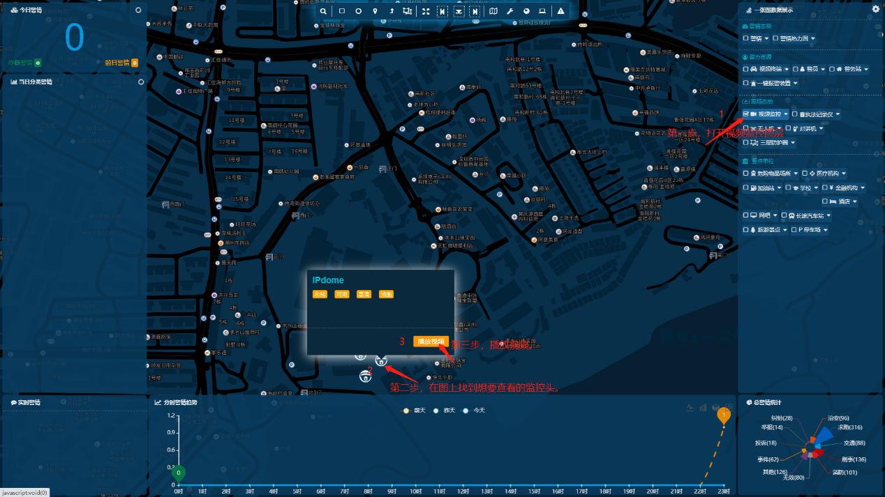
The first step is to open the "Video Surveillance"“视频监控” layer.
The second step is to find the monitor head(Command elements) you want to view on the map.
The third step, click the play video button.
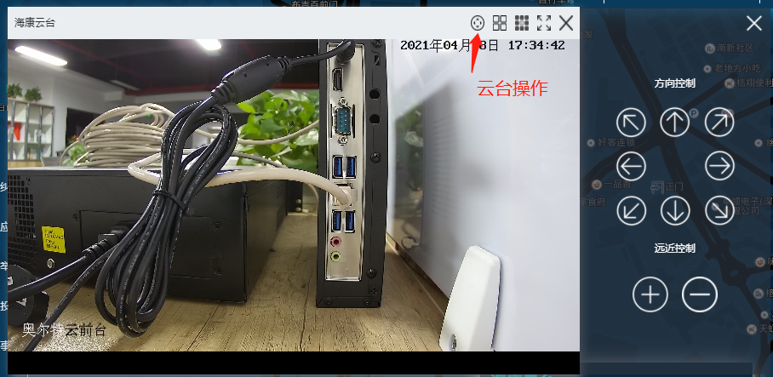
Support PTZ operation.

2、How to check the mobile video return？
1、First download the mobile version of The Police Treasure App from the Huawei App Market(AppGallery).
Turn on video postback.

2、On the App endpoint "Me", check which is the name of the currently logged-in account?
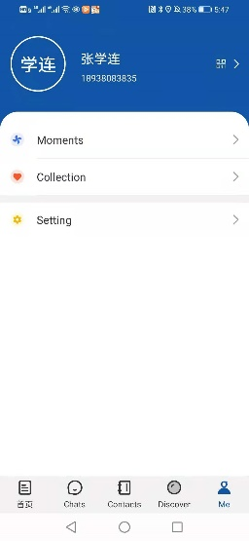
3、 Search for the video terminal on the map.
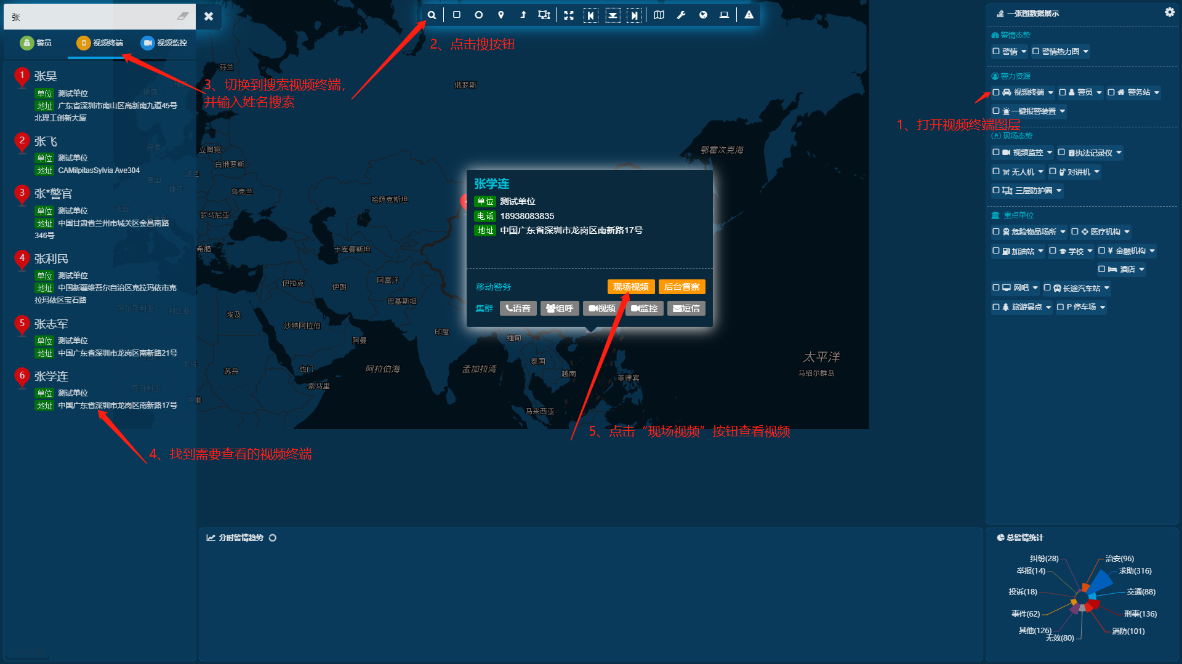
The first step is to open the video terminal layer(视频终端).
The second step is to click the search button on the toolbar.
The third step, in the search bar that comes out, click "Video Terminal"“视频终端”.
The fourth step, in the searched list, find the video terminal that needs to be viewed.
Step 5. Click the "Live Video"“现场视频” button. View the remote video return.

3、Executable program (.exe) version on Windows
You can download the EXE version at the link below.
https://www.oortschool.com/%E6%8C%87%E6%8C%A5%E8%B0%83%E5%BA%A6%E4%B8%80%E5%BC%A0%E5%9B%BE.exe

If the above link cannot be reached, you can go to the download page of the official website to download it.
https://onemap.oortcloudsmart.com/download.html

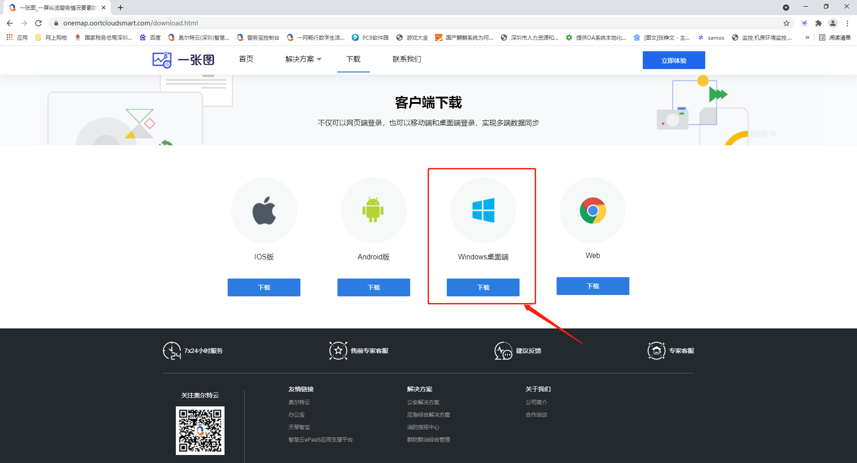

The interface after opening.
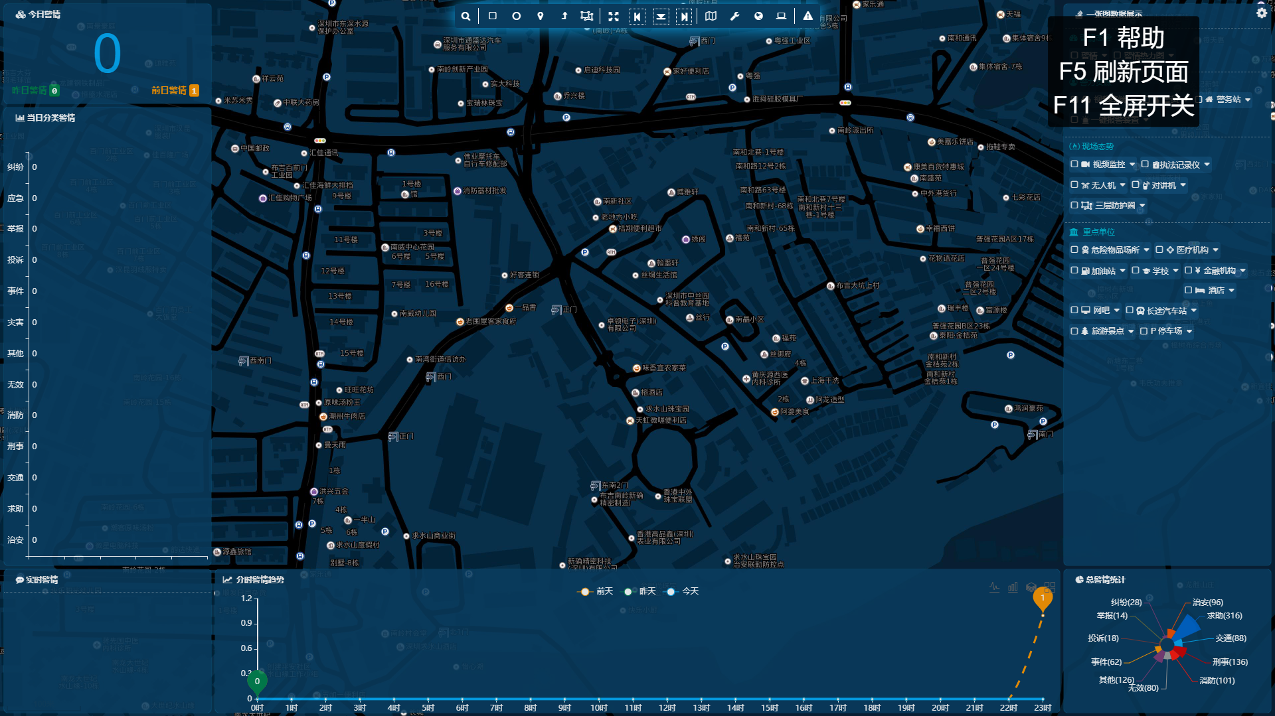
There is an EXE version, which can be opened directly on Windows.
In the EXE version, F1 help, F5 forced to refresh the page, F11 full screen switch.
This is a demo version of the EXE program. Double-click to open it to use, it requires Chrome browser to be installed.

4、Video conference
Enter the station linkage interface of the Police Treasure. Click the + sign to start the meeting.
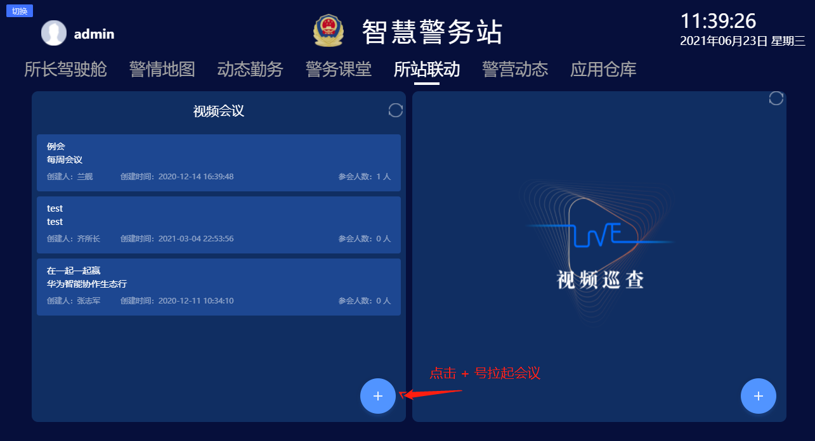

The Police Treasure mobile version passed  Enter the video conference, click to join the conference。
Fill in the meeting ID and password on the big screen. Enter the venue.
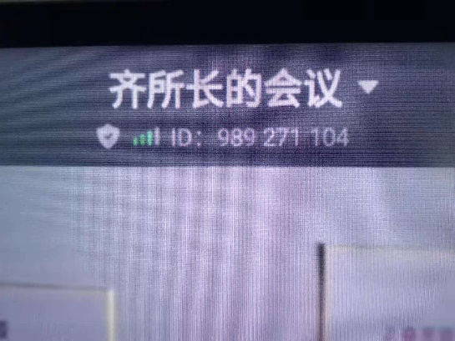  Tap the meeting name on the screen。 | 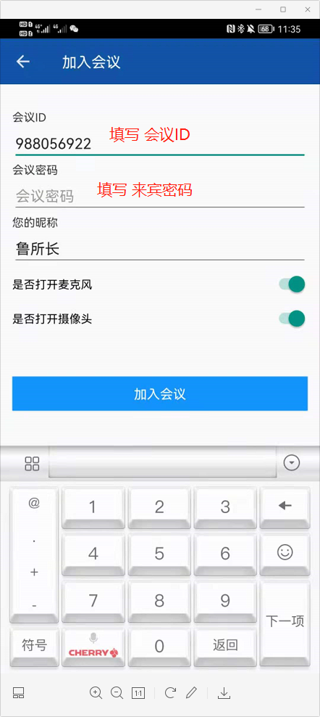  On the phone  Fill in the meeting ID and guest password to join the venue.
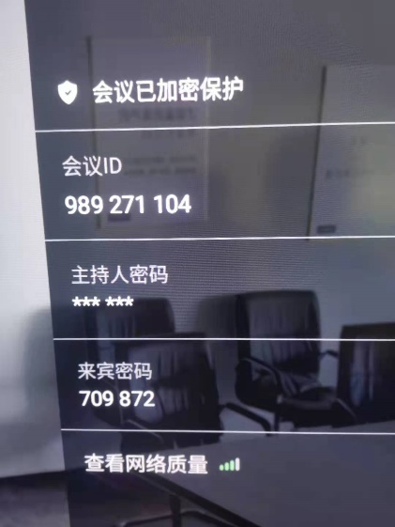
Fill in the conference ID and guest password into the parameters for joining the conference on the mobile phone.

Presentation renderings
1、Warning and heat map effect
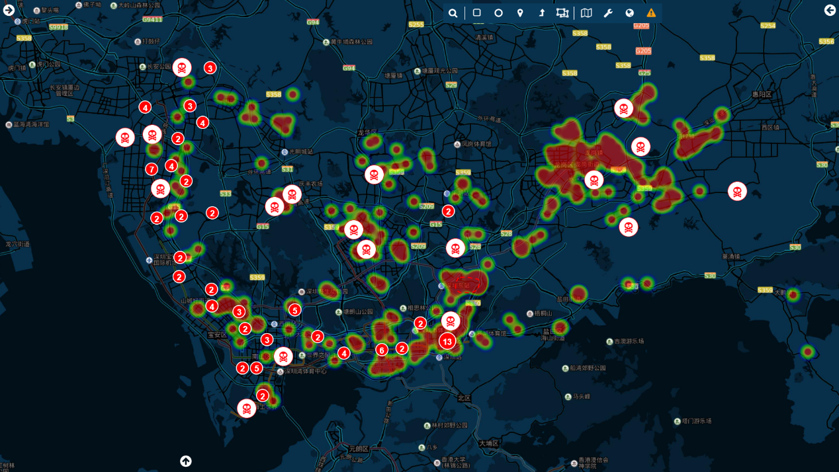

2、The effect of the surrounding command elements of the police situation
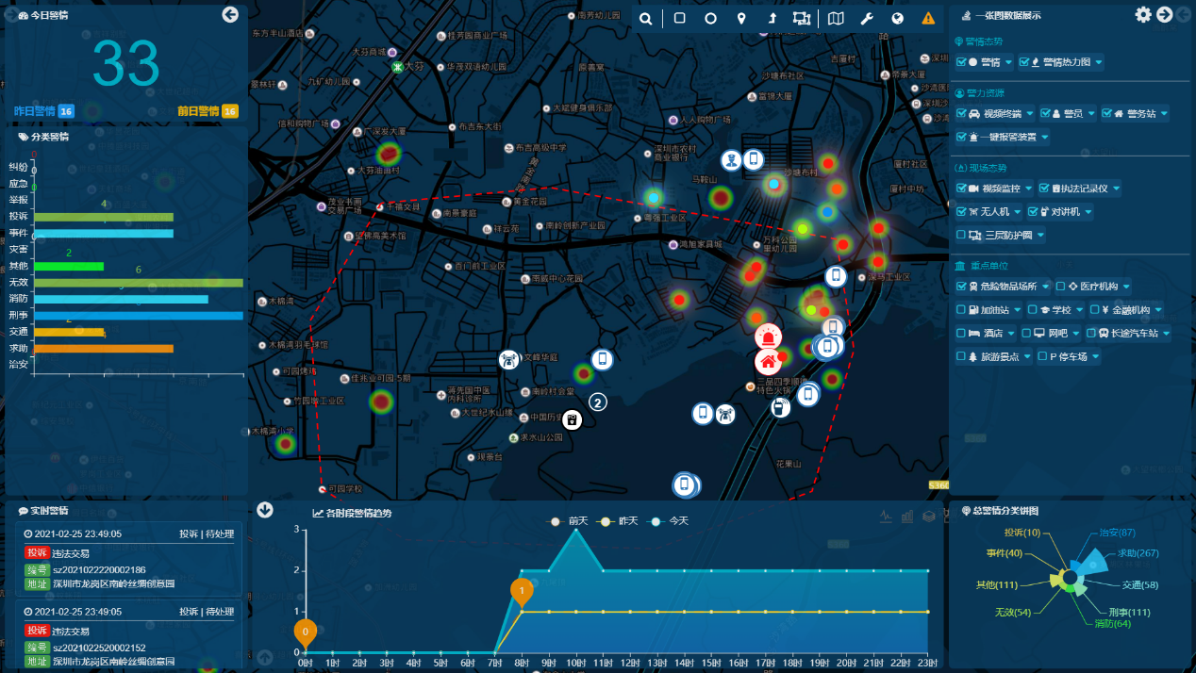

3、Tuning surveillance video effects
Supports a large number of GB/T28181 cameras, which can be connected to the platform or directly to the camera.
Comes with a visualized national standard (GB28181) video service platform
The visualized national standard (GB28181) video service platform is a highly available GB/T28181 national standard privately deployed streaming media server software, equipment or platform GB28181 standard protocol registration access, cascading upwards. Support full terminal playback, visual WEB page management, provide device status management, real-time check whether the device is offline and other information, support PTZ control, realize browser plug-in-free live broadcast. Provide an HTTP API interface called by a third party.
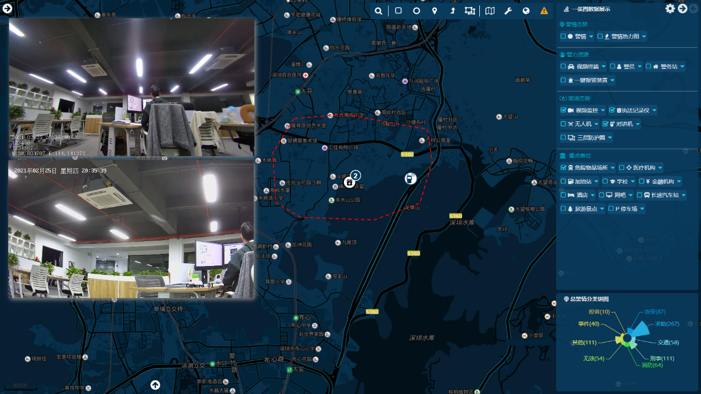
4、Query the historical track effect of police officers
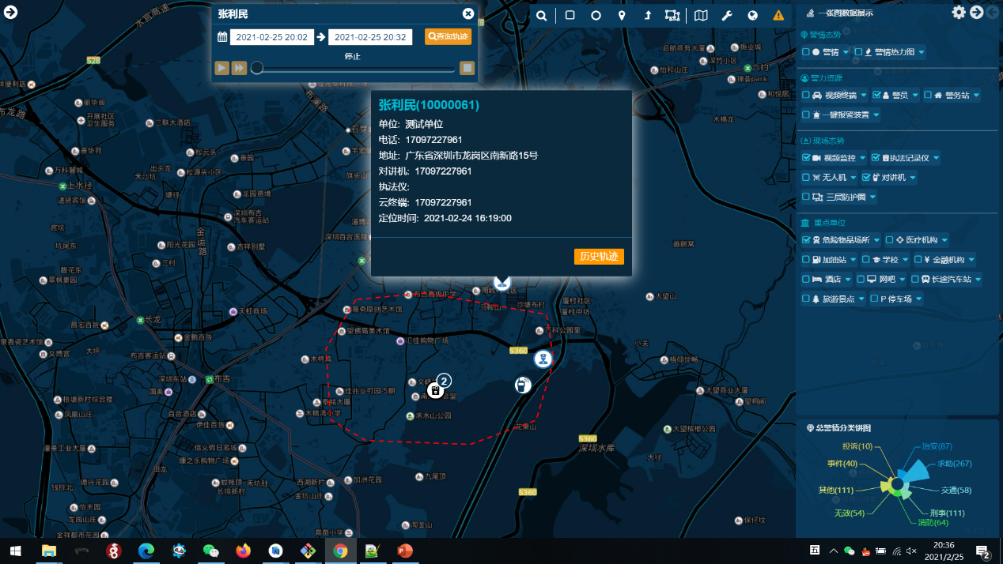

5、Light map effect
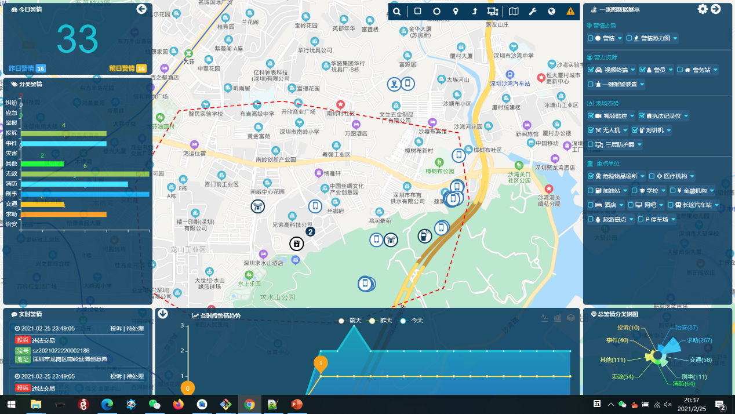
6、Image map effect
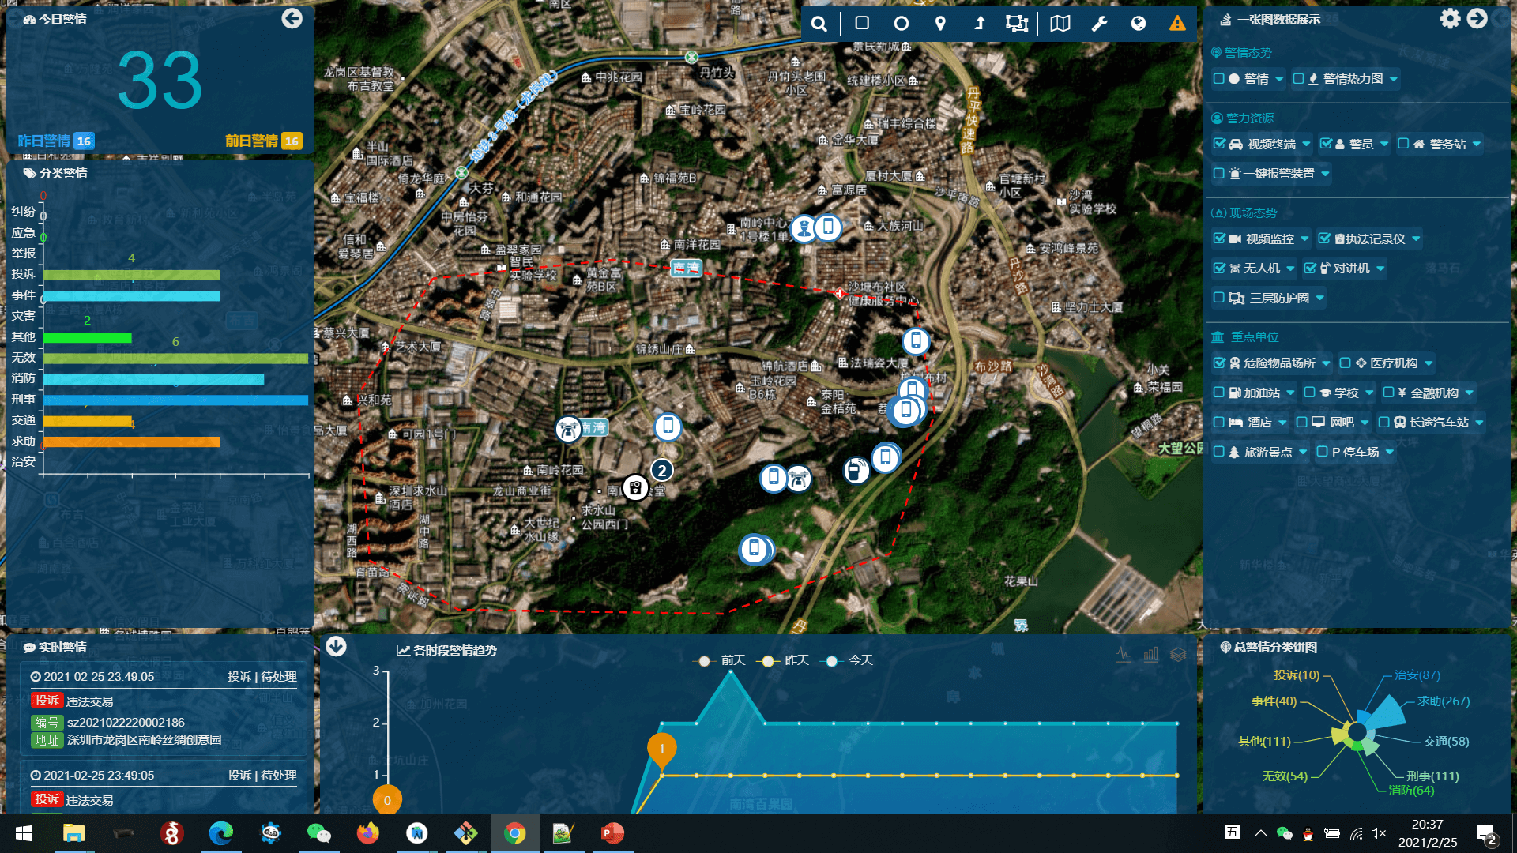

7、Space search command element effect
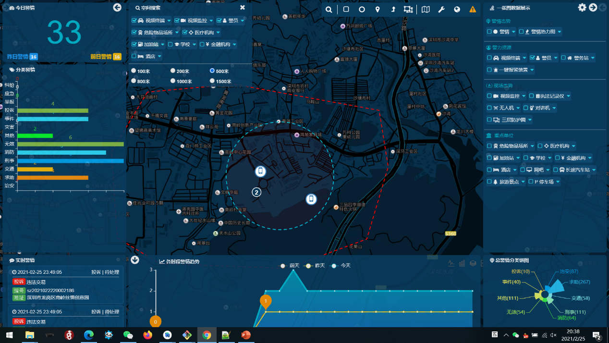

Attachment: Pingwubao background demonstration for customer-side operation and maintenance management

(In order to prevent multiple people from tampering, the account and password are not disclosed, if necessary, please ask Mr. Zhang Oortcloud(zhangxuelian@oortcloudsmart.com ) separately)

（一）Log in to the backstage of police treasure
http://map.oort.oortcloudsmart.com:31610/oort/oortcloud-policefront/console_manage/index.html#/
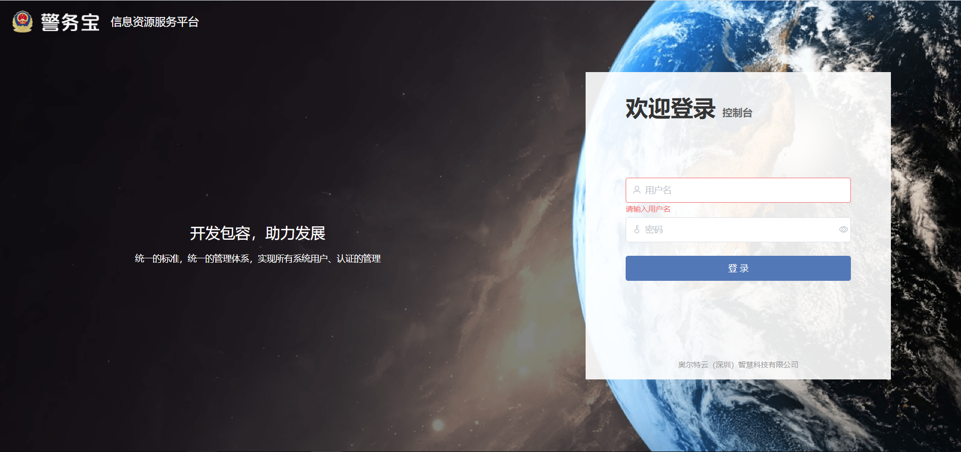

（二）Add users and organizations
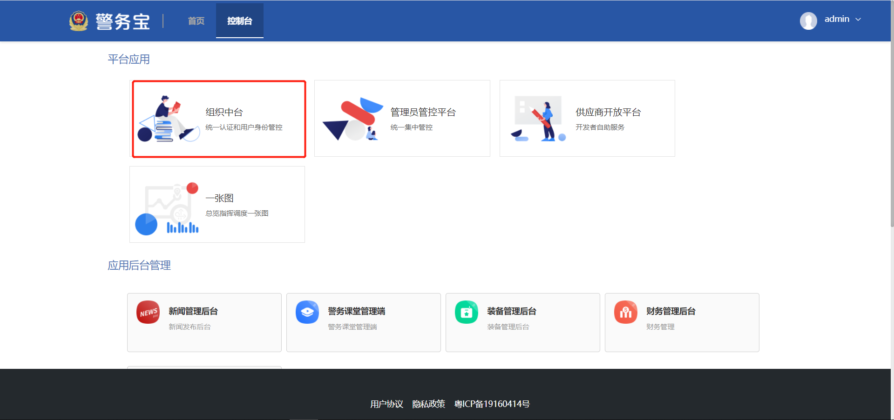

（三）Administrator control background
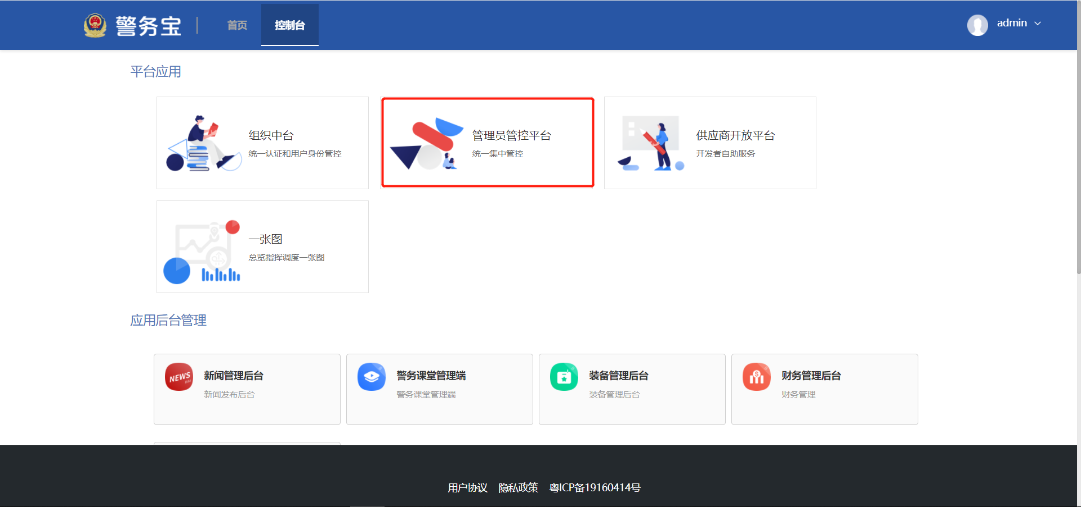

（四）App developer background
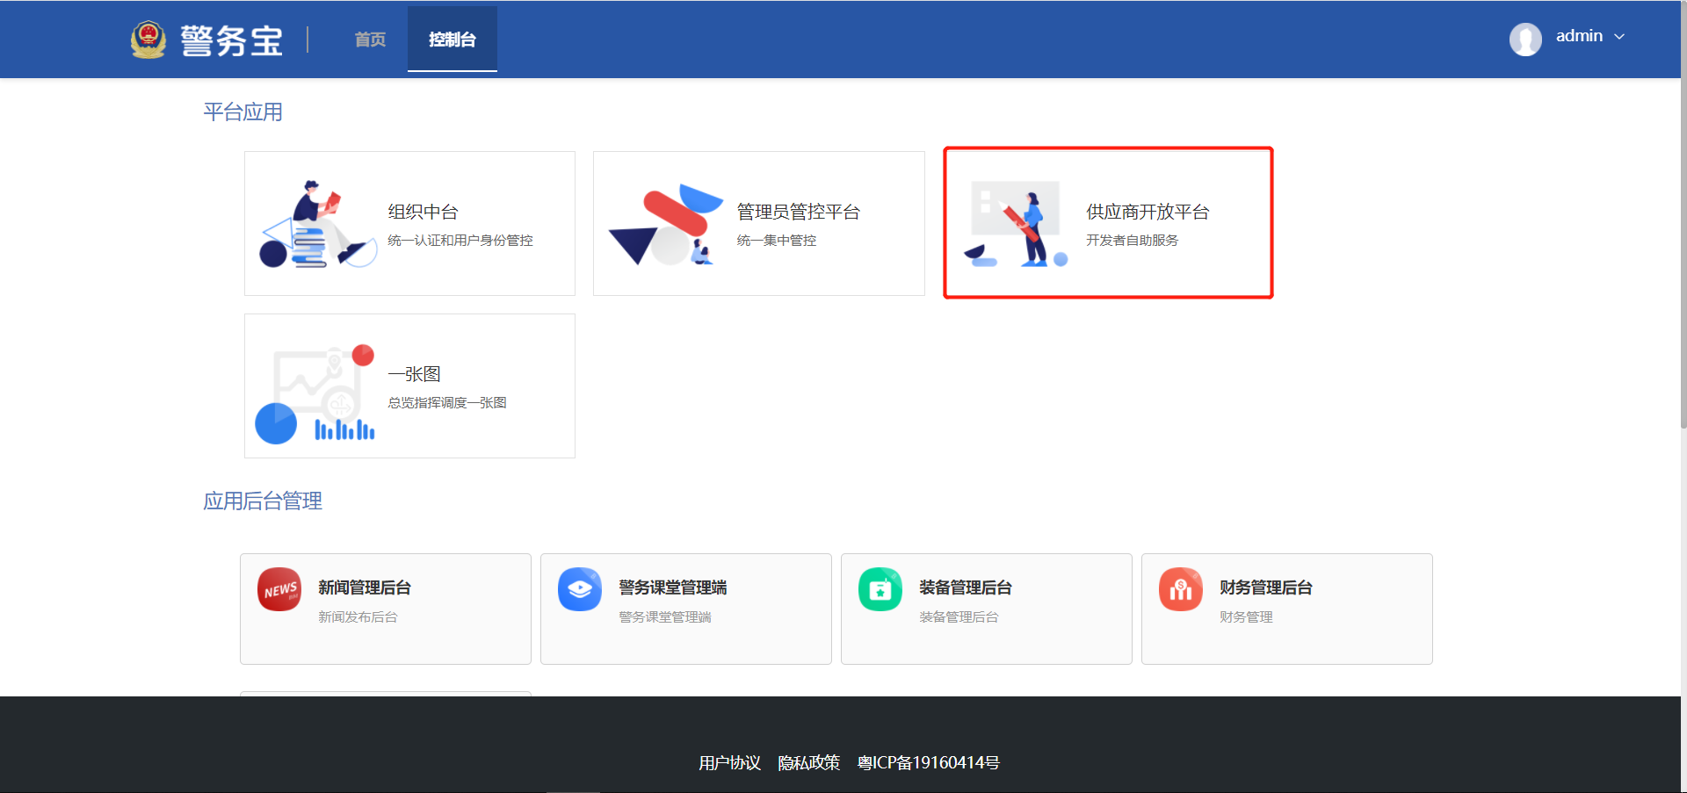

（五）One Map on the PC Web
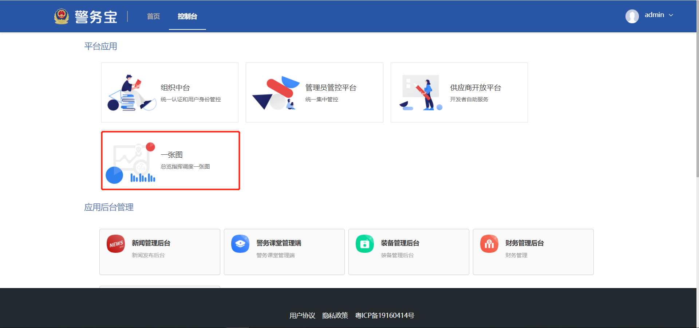

（六）App data management background
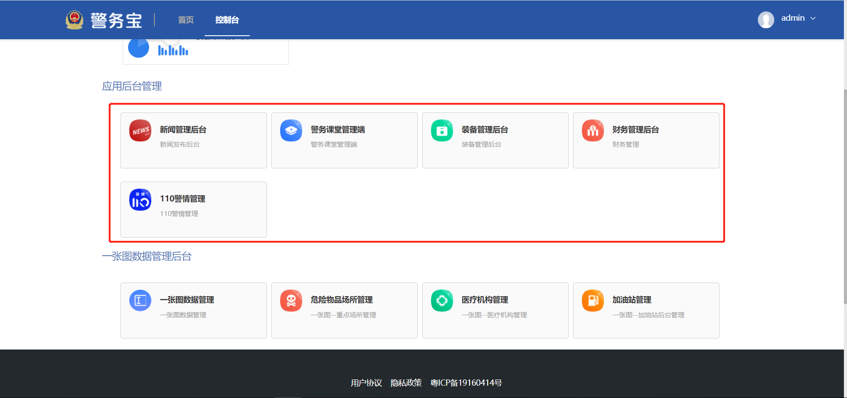

（七）110 police management background
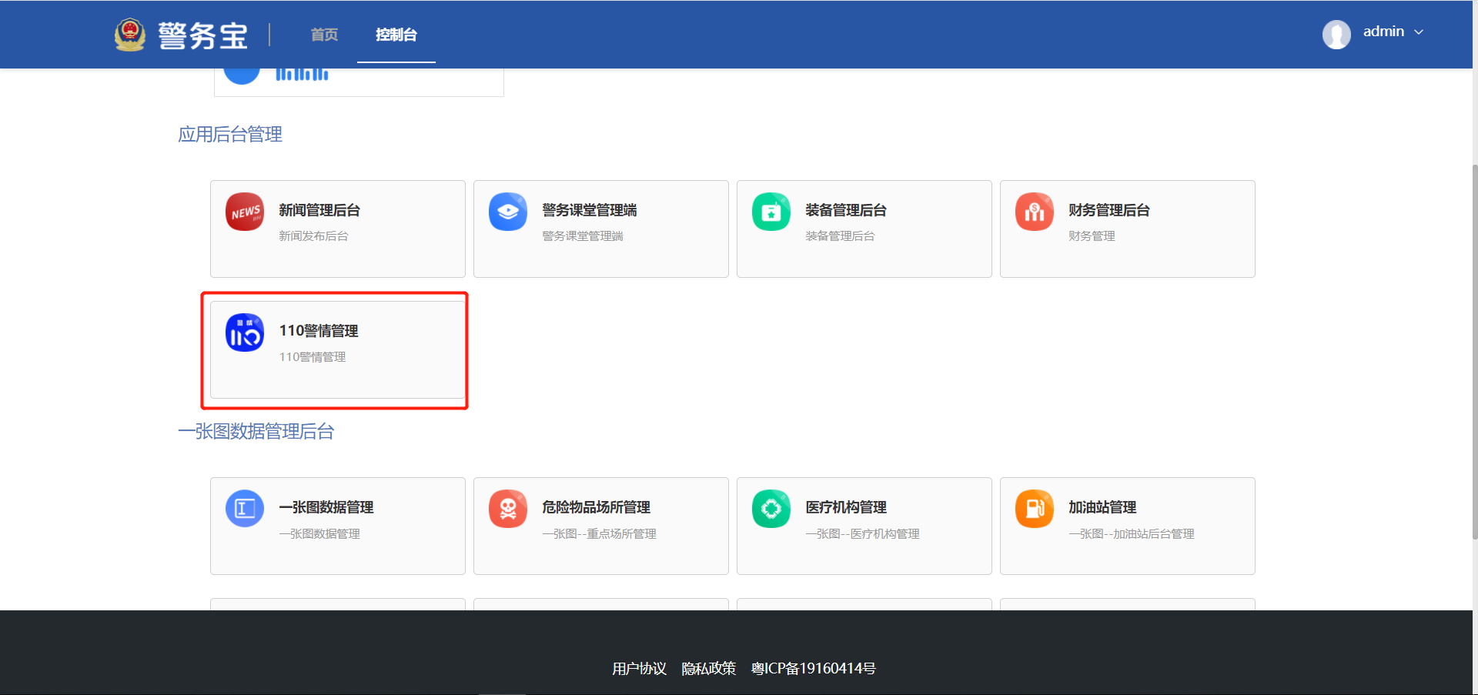

1、Police data can be recorded by hand
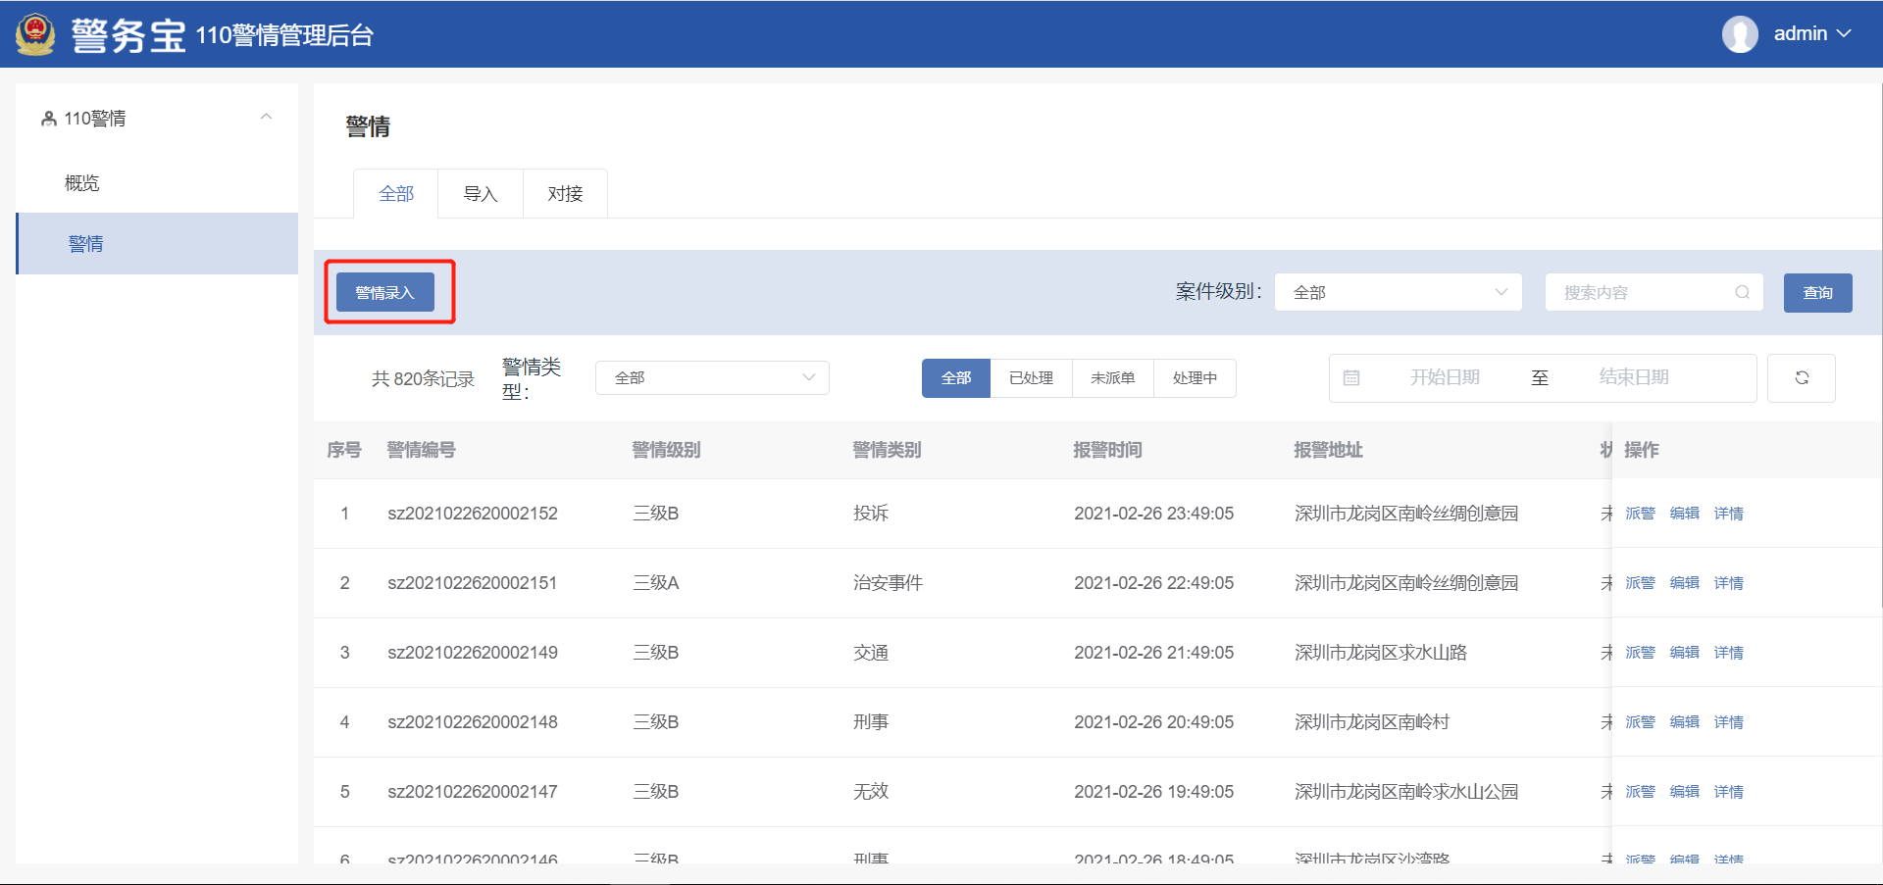

2、Alarm data can be imported in batches
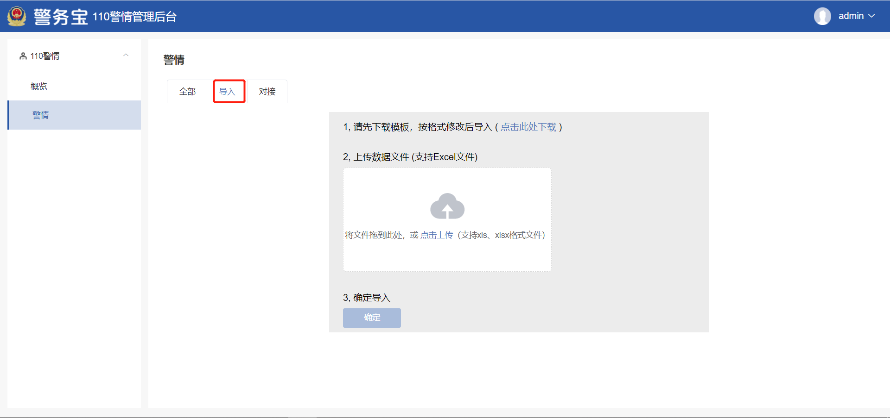

3、Alarm data can be docked
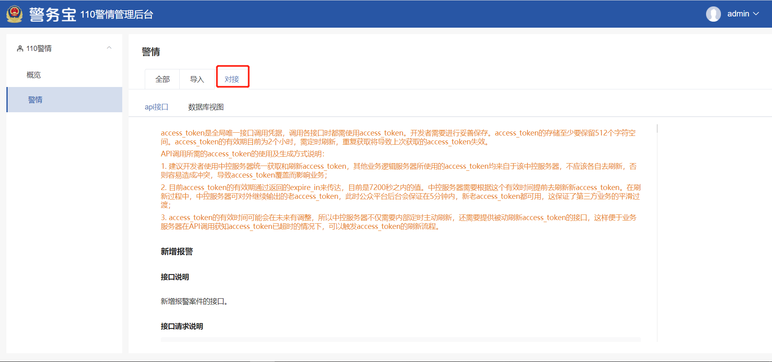

（八）One Map data management background
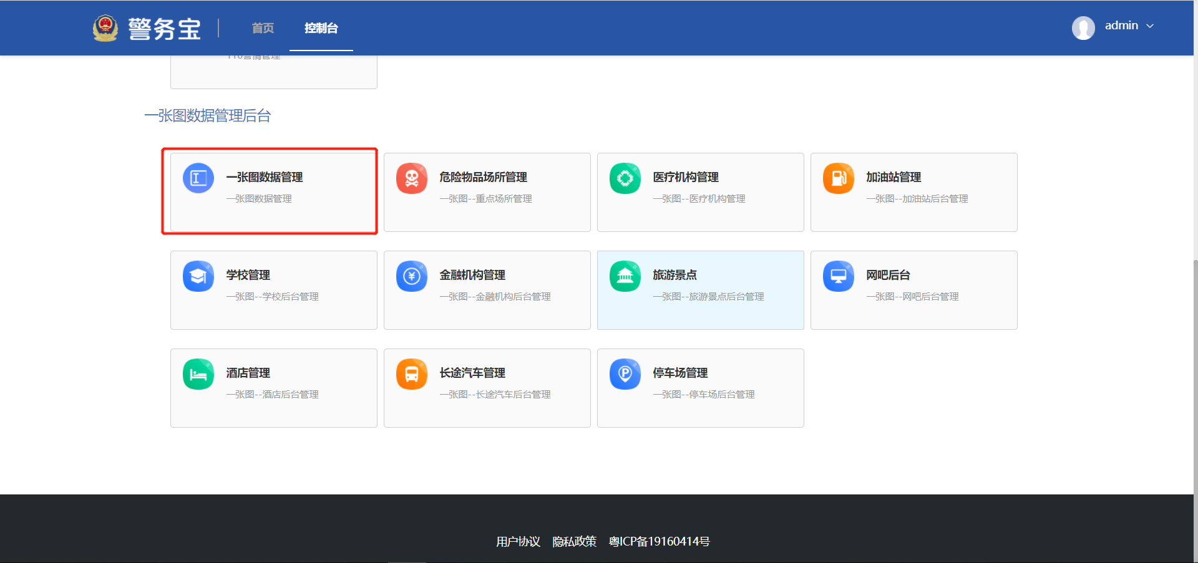
All data of One Map can be connected in three ways, manual recording, batch import and data connection
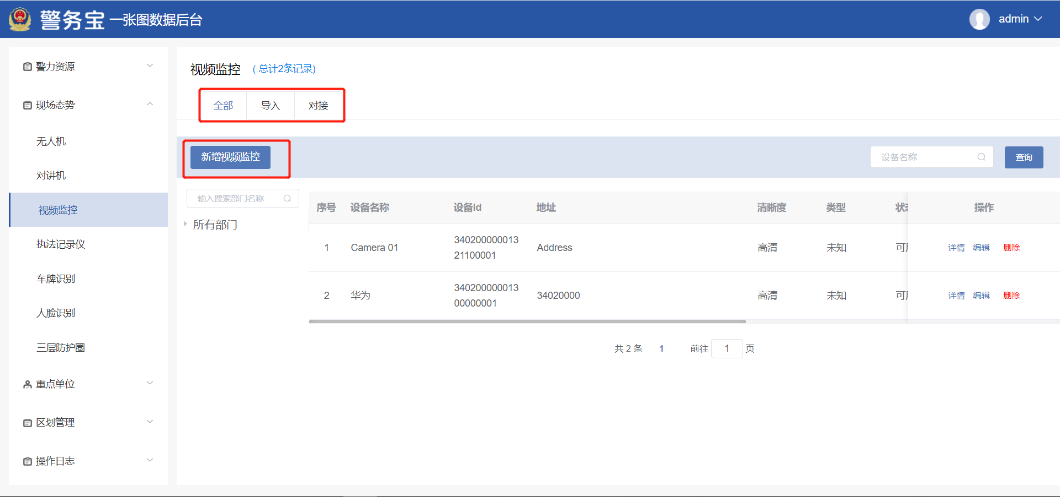

（九）Other data management background
