CIMC TRANSPACK IOT

一、【List of system features】

首页统计图 Home

设备管理 Device Monitoring

设备信息 Detailed Listing

历史轨迹 Location Tracks

地图定位 Current Location

传感器数据 Sensor Data

报警数据 Alarm Data

监控中心 Monitoring Center

多屏追踪 Multi-device Tracking

电子围栏 Geofence

围栏信息 Create

围栏配置 Pairing

围栏记录 Logs

设备配置 General Setting

参数设置 Device Parameter Setting

指令数据 Command data

报警设置 Alarm settings

下载中心 Download Center

下载列表 Download Center

二、【Instructions】

第一步：选择中英文切换，然后点击设备管理场景

Step 1: Select English and Chinese switch, then click Device Management

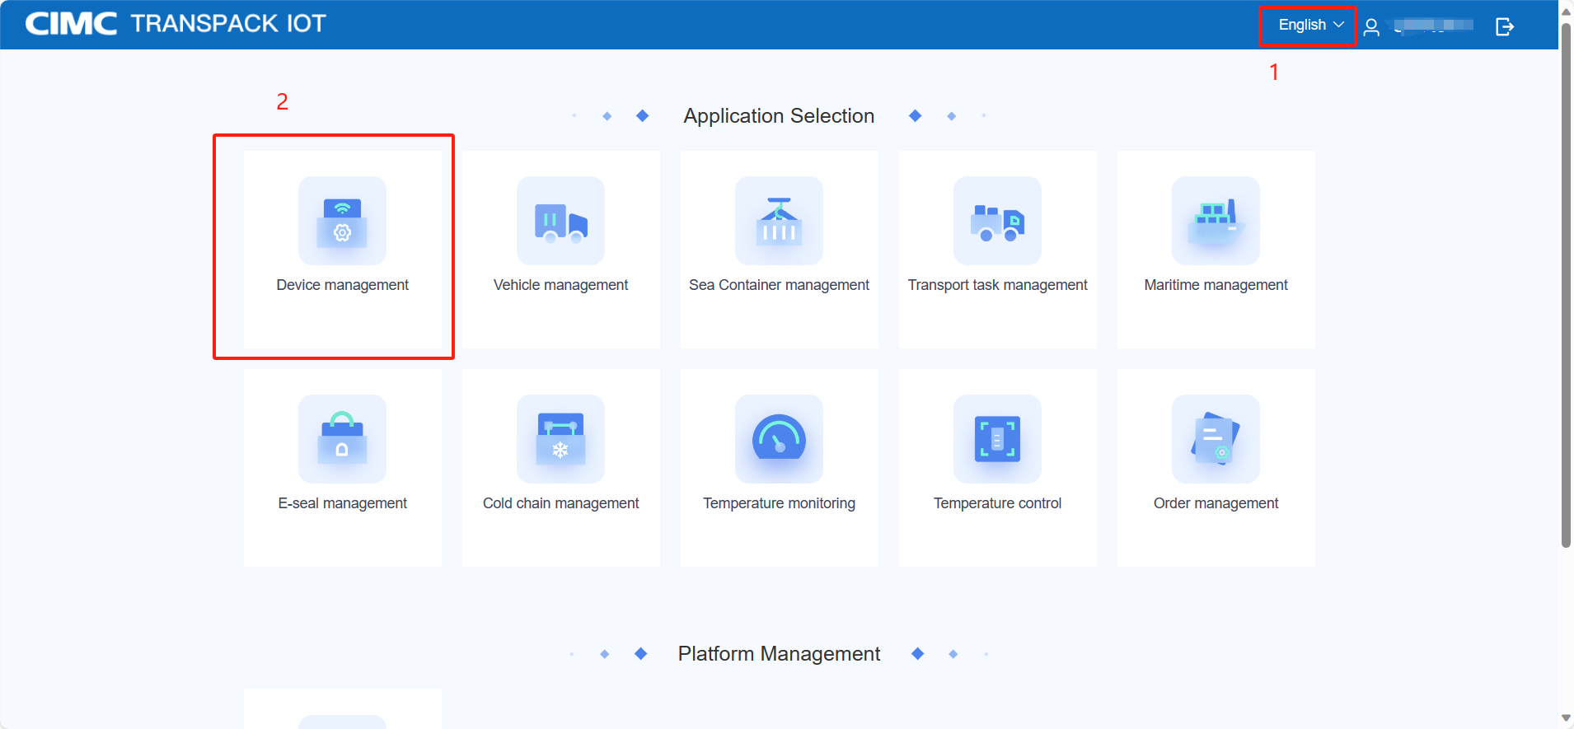

2.1【Home】

第一步：打开首页展示所有设备的统计情况。包括设备数量统计、报警数量统计、设备在线率、使用率、电子围栏出入记录统计等

Step 1: The home page displays the statistics of all devices. Including equipment quantity statistics, alarm quantity statistics, equipment online rate, utilization rate, electronic fence access record statistics

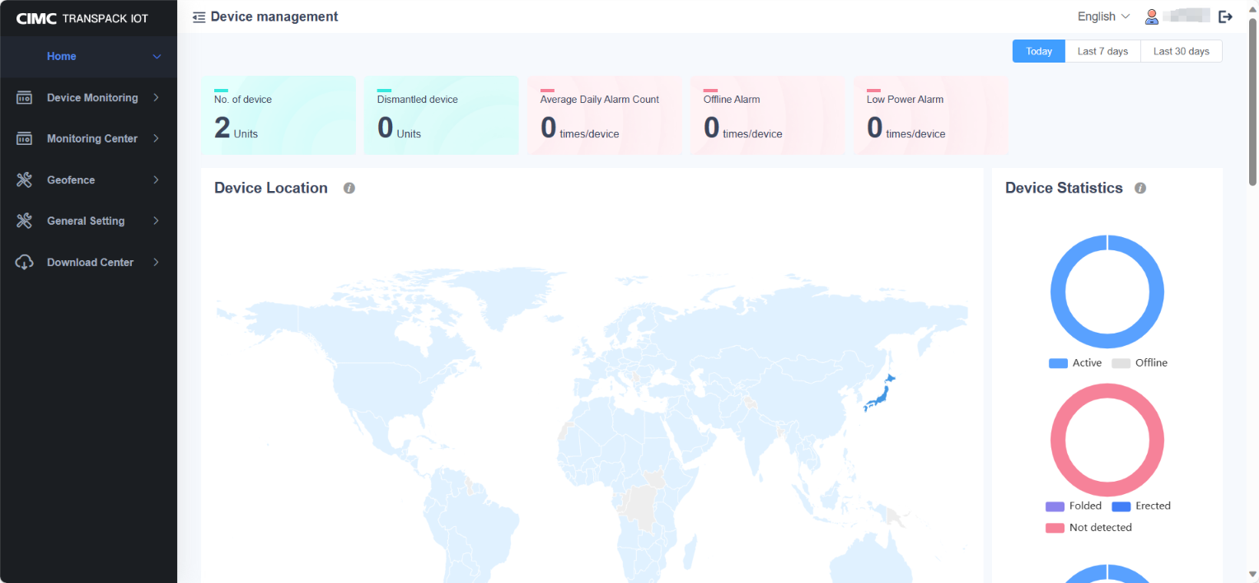

2.2【Device Monitoring】

第一步：设备列表展示所有设备的型号，实时电量，信号强度、空重状态、最新的定位位置，定位时间，拆卸状态，上报方式等

Step 1: Device list Displays the model, real-time power, signal strength, empty weight status, latest location, location time, disassembly status, and reporting mode of all devices

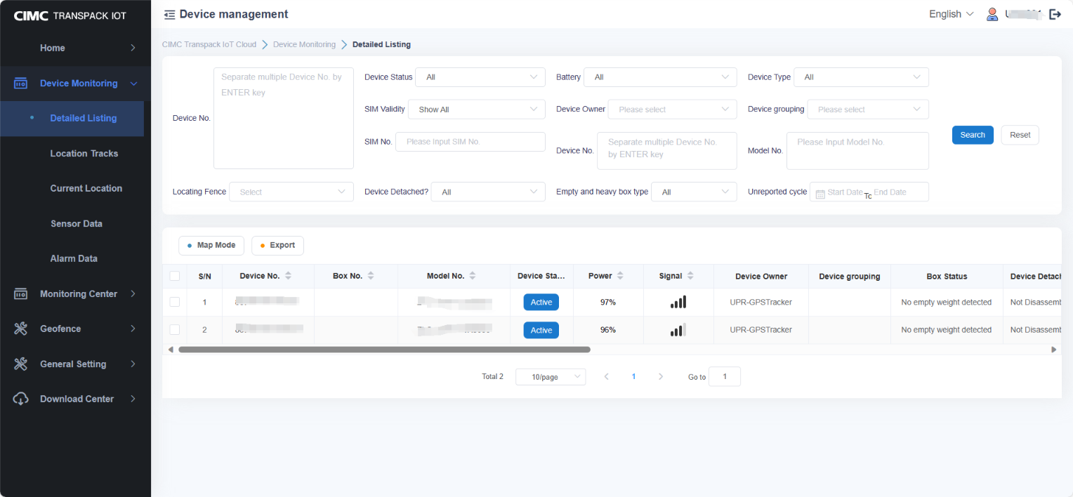

第一步：输入设备号，选择时间范围。可以查看到设备在某段时间范围内的移动轨迹

移动轨迹列表可以查看到所有的上报轨迹点的定位地址，上报的设备信息

勾选轨迹显示方式停留点、轨迹点、报警点、电子围栏。可以在地图实时标记出轨迹的情况

Step 1: Enter the device number and select a time range. You can view the movement trajectory of the device within a certain period of time Moving track list You can view the location addresses of all reported track points and reported device information Check the track display mode stop point, track point, alarm point, electronic fence. Tracks can be marked on the map in real time

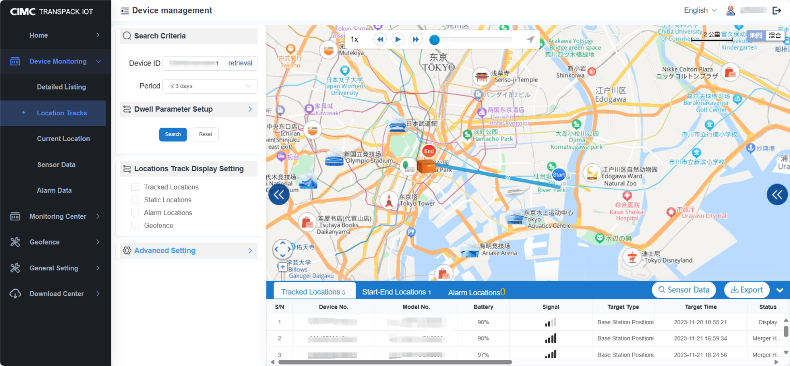

第一步：勾选设备号可以在地图上实时展示设备的地理位置，列表实时展示设备的信息，包括信号强度，地理位置地址、经纬度、电量、设备状态

可以在搜索框输入设备号进行搜索，设备列表数据可以导出

Step 1: Select the device number to display the geographic location of the device on the map in real time. The list displays the information of the device in real time, including signal strength, geographic location address, latitude and longitude, power, and device status You can enter the device number in the search box and export the device list data

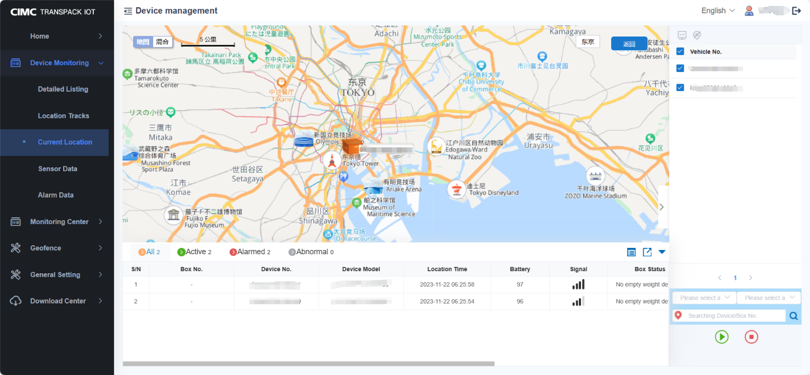

第一步：传感器数据列表记录设备在不同时间段的电量变化，温度变化、湿度变化、光感变化、震动变化等

Step 1: The sensor data list records the device's power changes, temperature changes, humidity changes, light changes, vibration changes, etc., in different time periods

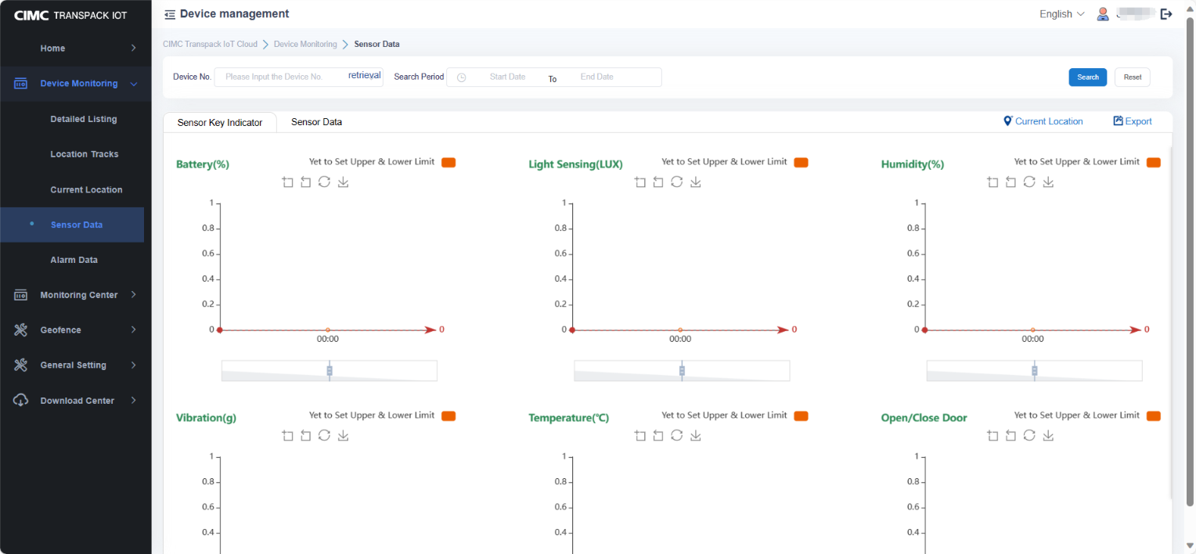

第一步：报警数据列表可以查看到所有设备的发生的报警记录

Step 1: The alarm data list allows you to view the alarm records of all devices

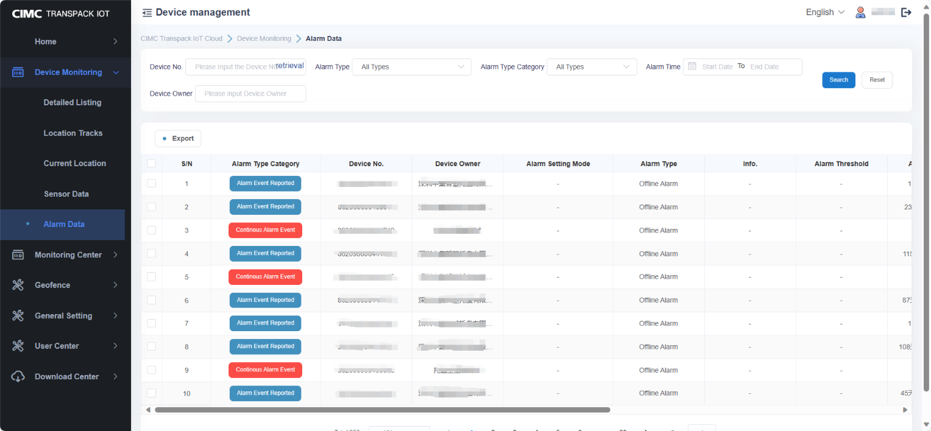

2.3【Electronic fence creation】

第一步：在电子围栏列表页面，选择新增/编辑

Step 1: On the Electronic fence list page, select Add/Edit

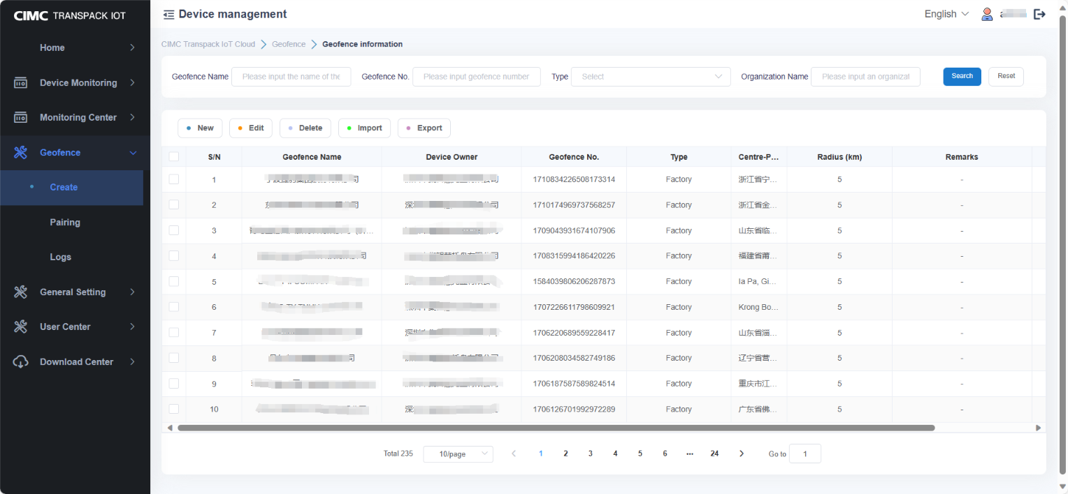

第二步：在电子围栏新增/编辑页面，点击右上角的定位按钮

Step 2: In the e-fence Add/edit page, click the positioning button in the upper right corner

第三步：在地图中点中工厂的具体位置，生成地图围栏

Step 3: Generate a map fence for the specific location of the factory in the map point

第四步：录入电子围栏的名称，录入电子围栏的范围

Step 4: Enter the name of the electronic fence, enter the scope of the electronic fence

第五步：选择电子围栏的类型，录入备注信息等

Step 5: Select the type of electronic fence, input remarks and so on

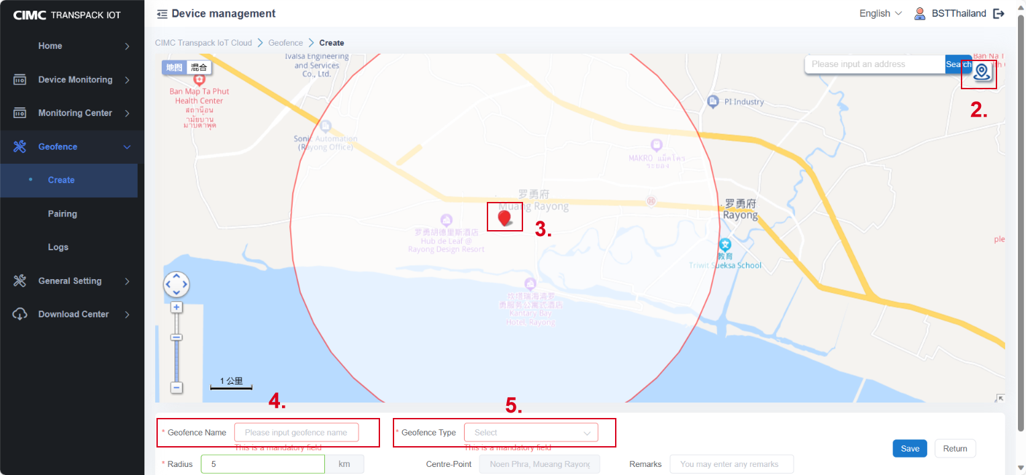

第六步：在电子围栏配置列表页面，点击围栏配置

Step 6: On the Electronic fence Configuration list page, click Fence Configuration

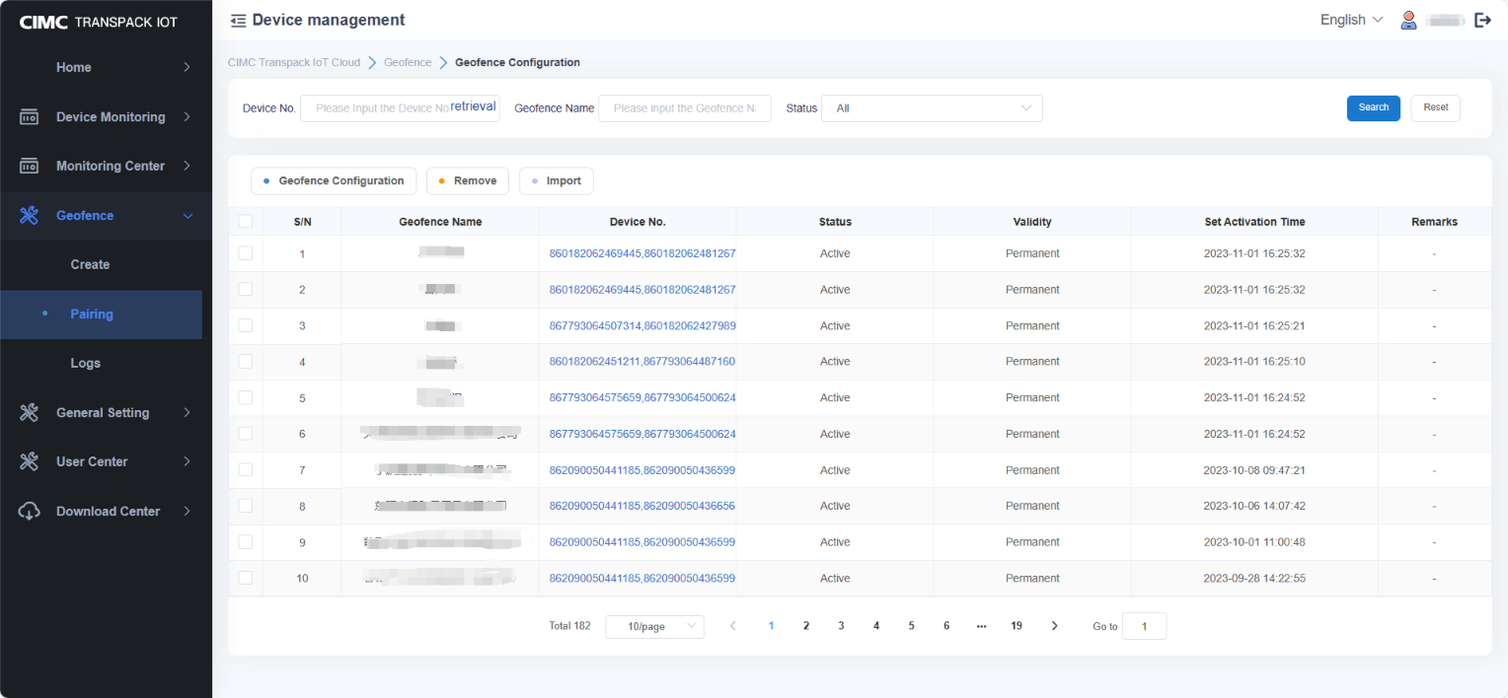

第七步：选择围栏要检测的设备组织

Step 7: Select the equipment organization for the fence to be tested

第八步：选择围栏要检测的设备

Step 8: Select the equipment the fence is to detect

第九步：选择需要配置检测能力的电子围栏

Step 9: Select the electronic fence that needs to be configured with detection capabilities

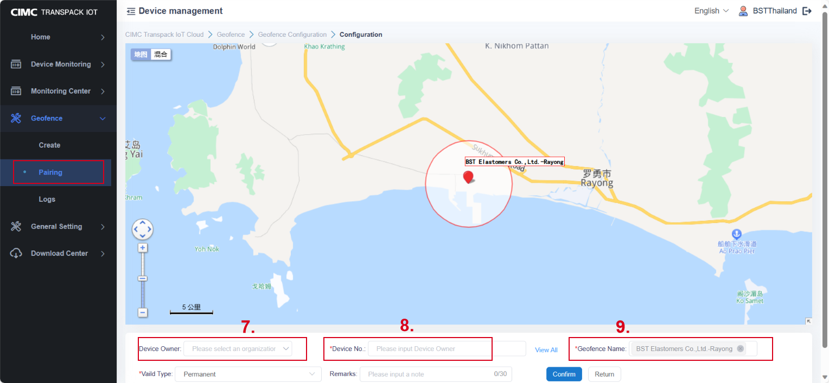

第十步：在围栏记录页面查看设备的出库、入库记录

Step 10: Check the exit and entry records of the equipment on the fence record page

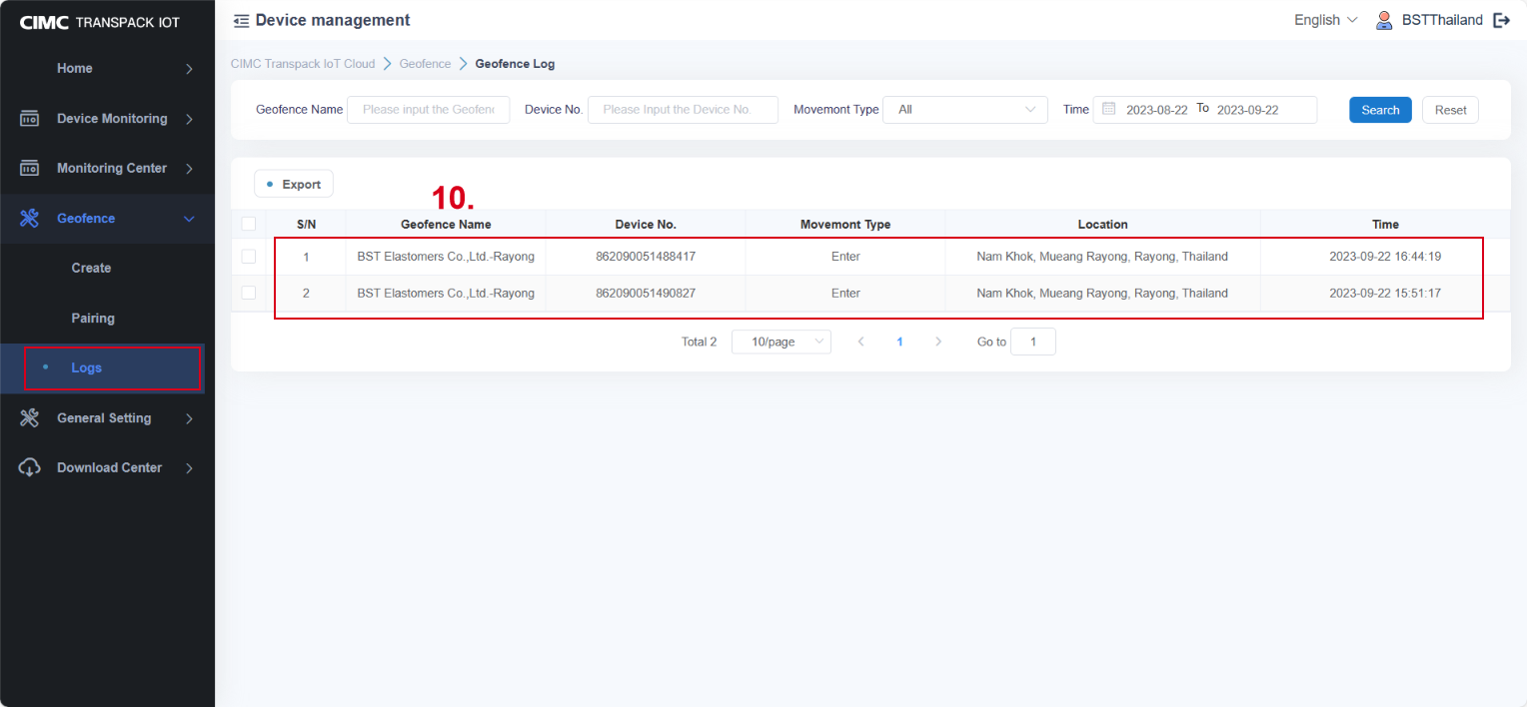

2.4【General Setting】

第一步：勾选设备在点击设备参数设置，可以配置设备的上报方式。按照时间间隔上报数据或者按照具体时间上报数据。向设备发送指令

Step 1: Select devices and click Device Parameter Settings to configure the device reporting mode. Report data by time interval or by specific time. Send instructions to the device

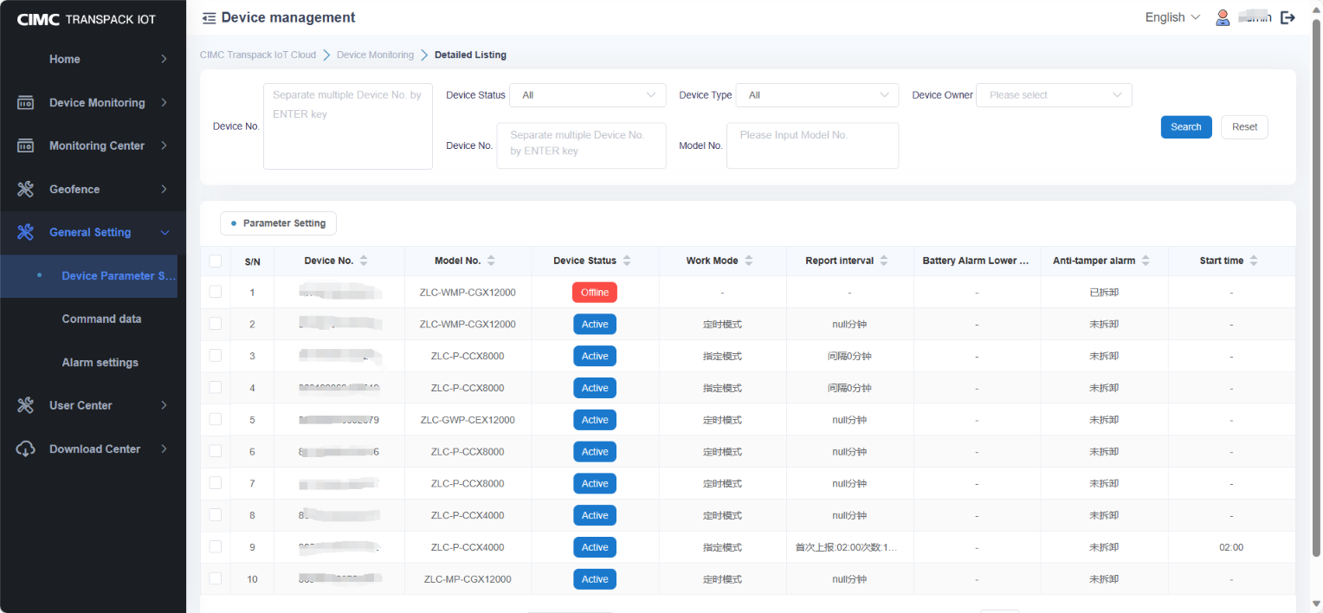

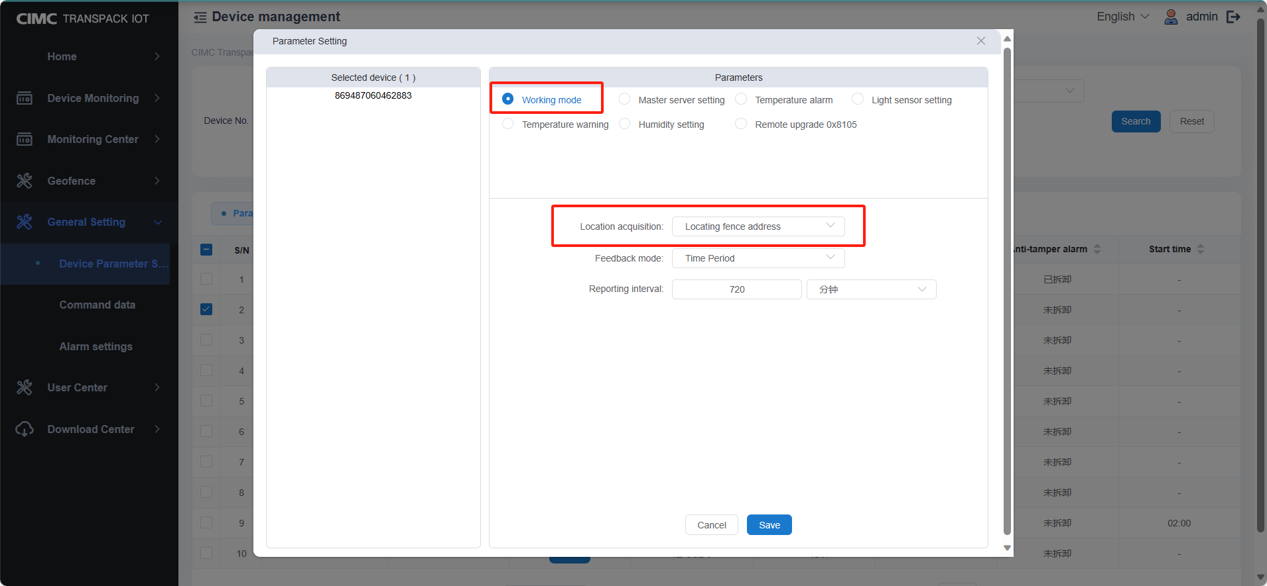

第一步：指令数据列表可以查看到向所有设备下发的指令记录

Step 1: Command data list You can view the command records delivered to all devices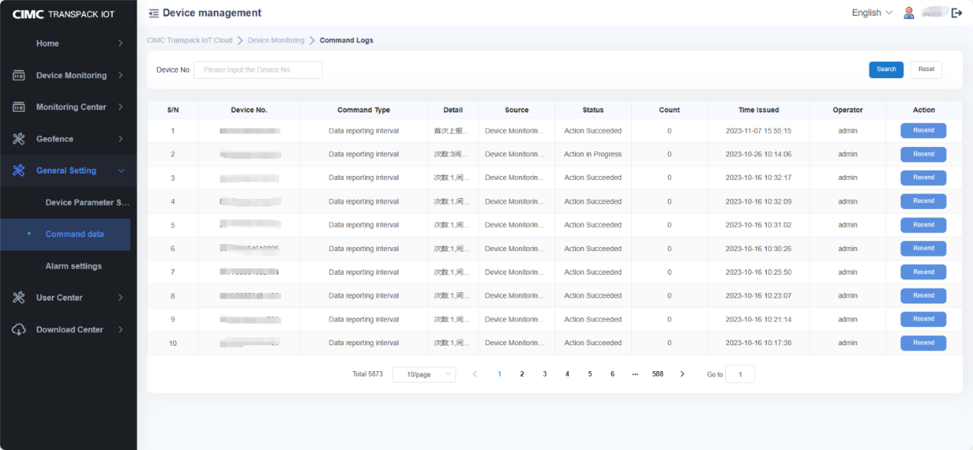

第一步：报警策略可以配置并查看到设备的报警类型、报警方式。点击新增报警、勾选报警策略点击编辑

Step 1: Alarm policy You can configure and view the alarm type and alarm mode of the device. Click Add alarm, check alarm policy and click Edit

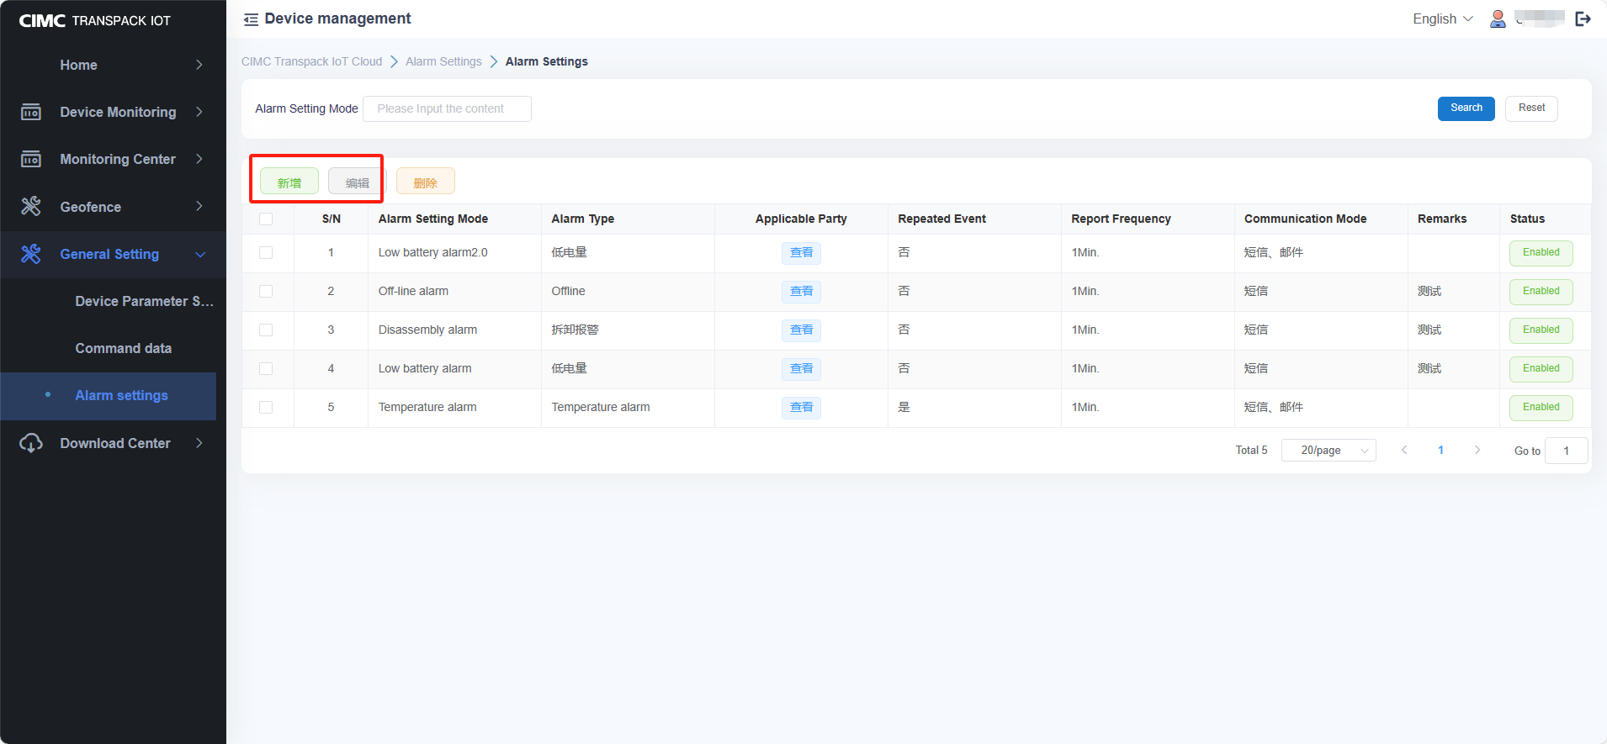

第二步： 报警策略可以配置并查看到设备的报警类型、报警方式

录入报警策略名称和选择报警类型(离线报警、低电量报警、拆卸报警)设置参数

低电量报警：设置最低多少电量触发报警

选择当前报警策略需要检测的设备，最后选择报警的推送方式(短信、邮件)

Step 2: Alarm policy You can configure and view the alarm type and alarm mode of the device Enter alarm policy name and select alarm type (offline alarm, low power alarm, disassembly alarm) and set parameters Low power alarm: Set the minimum power to trigger the alarm Select the device that needs to be detected in the current alarm policy, and finally select the push mode of alarm (SMS, email).

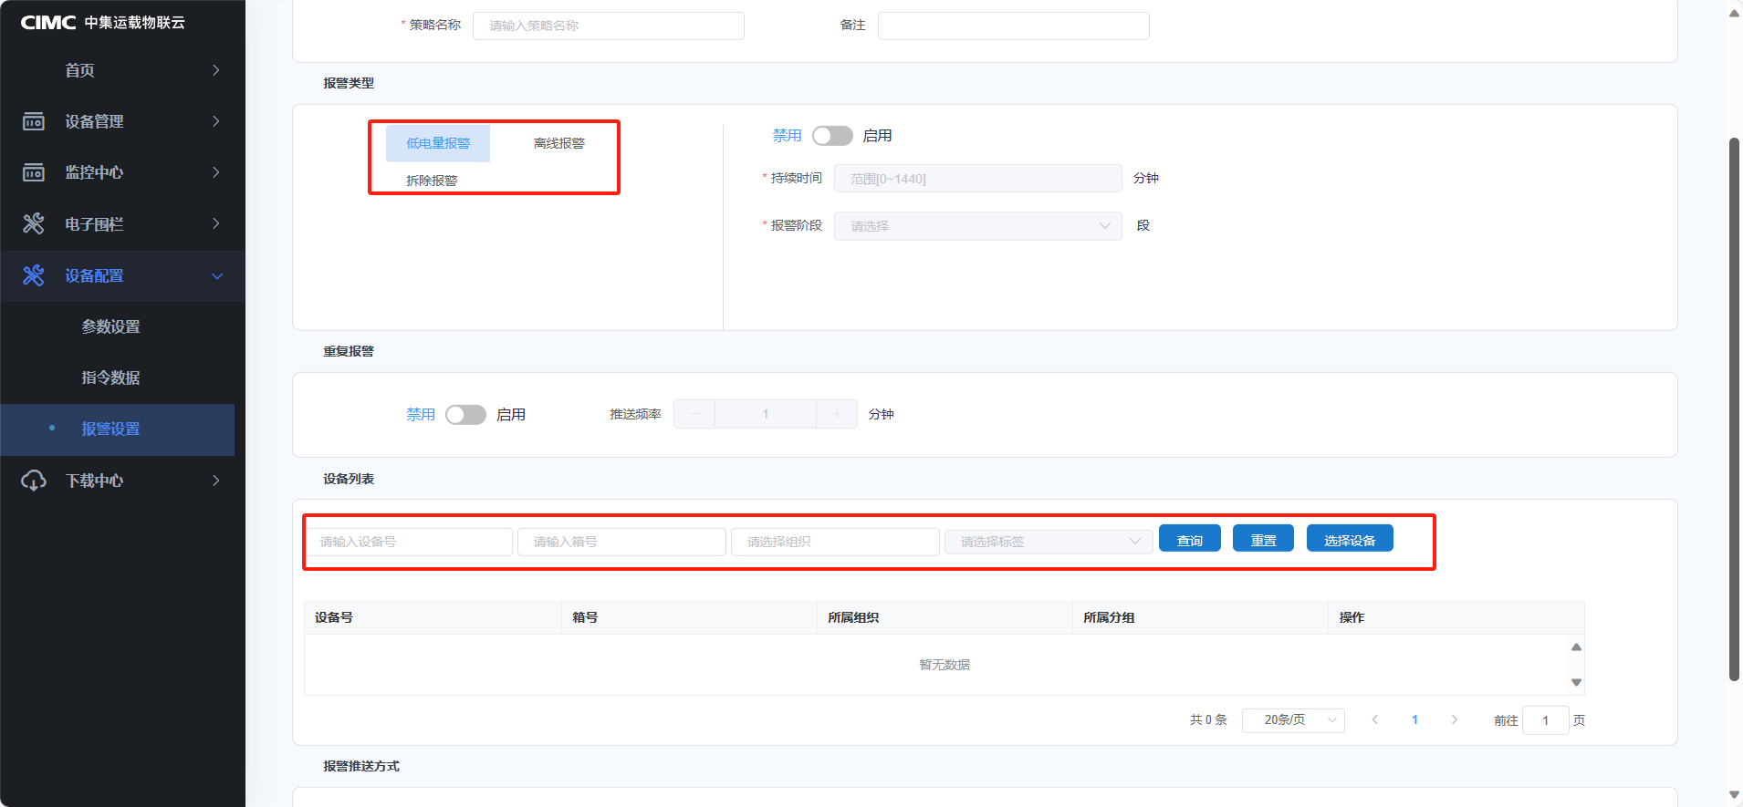

2.5【Download Center】

第一步：打开下载中心可以看到系统导出的所有文件，点击下载文件到本地

Step 1: Open the Download center to view all the files exported by the system. Click Download File to local

